**DEPARTMENT OF COMPUTER APPLICATION**

**TKM COLLEGE OF ENGINEERING KOLLAM – 691005**



**20MCA133 – WEB PROGRAMMING LAB**

PRACTICAL RECORD BOOK

First Semester MCA 2021-2022

**Submitted by:**

NAME: ARUN UDAY

REG NO: TKM21MCA-2011

**DEPARTMENT OF COMPUTER APPLICATION**

**TKM COLLEGE OF ENGINEERING**

**KOLLAM – 691005**



**Certificate**

This is a bonafide record of the work done by **ARUN UDAY** (TKM21MCA-2011) in the First Semester in Web Programming Lab Course(20MCA133) towards the partial fulfilment of the degree of Master of Computer Applications during the academic year 2021-2022.

Staff Member in-charge Examiner

……………………….. ………………………..

**INDEX**

|  |  |  |  |
| --- | --- | --- | --- |
| **Program No:** | **Programs** | | **Page No:** |
|  | **LAB CYCLE 1** | |  |
|  | 1.1 | Introduction about HTML | 1 |
| 1 | 1.2 | Model a simple HTML file to demonstrate the use of different tags. | 3 |
| 2 | 1.3 | Create a HTML file to link to different HTML page which contains images, tables, and also link within a page. | 7 |
| 3 | 1.4 | Create a HTML page with different types of frames such as floating frame, navigation frame & mixed frame. | 13 |
| 4 | 1.5 | Analyze CSS by applying the different styles using inline, external & internal style sheets in a HTML file. | 18 |
| 5 | 1.6 | Demonstrate a registration form using HTML. | 24 |
|  | **LAB CYCLE 2** | |  |
|  | 2.1 | Introduction to Javascript | 30 |
| 6 | 2.2 | Create a HTML page to explain the use of various predefined functions in a string and math object in java script. | 31 |
| 7 | 2.3 | Generate the calendar using JavaScript code by getting the year from the user. | 40 |
| 8 | 2.4 | Create a HTML registration form and to validate the form using JavaScript code. | 45 |
| 9 | 2.5 | Evaluating JavaScript Event Handling for every click of a button to change the background color of a HTML page. | 51 |
| 10 | 2.6 | Create a HTML page to display a new image and text when the mouse comes over the existing content in the page using JavaScript Event Handling. | 53 |
| 11 | 2.7 | Create a HTML page to show online exam using JavaScript. | 55 |
|  | **LAB CYCLE 3** | |  |
|  | 3.1 | Introduction to PHP & MySQL | 58 |
| 12 | 3.2 | Develop a PHP program to connect to a database and retrieve data from a table and show the details in a neat format. | 60 |
|  | **LAB CYCLE 4** | |  |
| 13 | 4.1 | Outline a registration form using PHP and do necessary validations. | 62 |
| 14 | 4.2 | Compose Electricity bill from user input based on a given tariff using PHP | 66 |
| 15 | 4.3 | Build a PHP code to store name of students in an array and display it using print_r function. Sort and Display the same using asort & arsort functions. | 70 |
| 16 | 4.4 | Build a PHP code to store name of Indian Cricket players in an array and display the same in HTML table. | 72 |
|  | **LAB CYCLE 5** | |  |
| 18 | 5.1 | Using PHP and MySQL, develop a program to accept book information viz. Accession number, title, authors, edition and publisher from a web page and store the information in a database and to search for a book with the title specified by the user and to display the search results with proper headings. | 75 |
| 19 | 5.2 | Develop a web application for Airline Reservation System using any PHP framework (Laravel, CodeIgniter, Symfony, CakePHP etc.). | 79 |

# HTML (HYPERTEXT MARKUP LANGUAGE)

HTML is the language for publishing web pages on the WWW. It is a Document Description Language. HTML is NOT a programming language like C/C++/C#/Java, which is used to implement programming algorithm

An HTML **element** is defined by a start tag, some content, and an end tag:Content goes here..</tagname> The HTML element is everything from the start tag to the end tag:

<h1>My First Heading</h1>

<p>My first paragraph. </p>

HTML **tables** allow web developers to arrange data into rows and columns. The <table> tag defines an HTML table.e. Each table row is defined with a <tr> tag. Each table header is defined with a <th> tag.

Each table data/cell is defined with a <td> tag. By default, the text in elements <th> are bold and centered. By default, the text in elements <td> are regular and leftaligned.

HTML **lists** allow web developers to group a set of related items in lists. HTML lists allow web developers to group a set of related items in lists. An ordered list starts with the <ol> tag. Each list item starts with the <li> tag. The list items will be marked with numbers by default.HTML also supports description lists. A description list is a list of terms, with a description of each term.The <dl> tag defines the description list, the <dt> tag defines the term (name), and the <dd> tag describes each term.

An HTML **form** is used to collect user input. The user input is most often sent to a server for processing. The HTML <form> element is used to create an HTML form for user input.The <form> element is a container for different types of input elements, such as: text fields, checkboxes, radio buttons, submit buttons, etc. The HTML <input> element is the most used form element. An <input> element can be displayed in many ways, depending on the type attribute. The <label> tag defines a label for many form elements. The <input type=”radio”> defines a radio button. The <input type=”checkbox”> defines a checkbox. Checkboxes let a user select ZERO or MORE options of a limited number of choices. The <input type=”submit”> defines a button for submitting the form data to a form-handler. The form-handler is typically a file on the server with a script for processing input data. The formhandler is specified in the form's action attribute.

# CSS (CASCADING STYLE SHEET)

Cascading Style Sheets (CSS) is a style sheet language used for describing the presentation of a document written in a markup language such as HTML. CSS is a cornerstone technology of the World Wide Web, alongside HTML and JavaScript.

CSS is designed to enable the separation of presentation and content, including layout, colors, and fonts. This separation can improve content accessibility, provide more flexibility and control in the specification of presentation characteristics, enable multiple web pages to share formatting by specifying the relevant CSS in a separate .css file which reduces complexity and repetition in the structural content as well as enabling the .css file to be cached to improve the page load speed between the pages that share the file and its formatting.

There are 3 ways to implement CSS in a HTML Page, they are :

**1.INLINE CSS**

**2.INTERNAL CSS**

**3.EXTERNAL CSS**

**PROGRAM NO: 1**

**AIM:** Model a simple HTML file to demonstrate the use of different tags.

**DESIGN:**

1. Create an html page containing different tags.

2. Create a CSS file for styling.

**SOURCE CODE:**

|  |  |
| --- | --- |
| index.html | <html lang="en">  <head>  <meta charset="UTF-8">  <meta name="viewport" content="width=device-width, initial-scale=1.0">  <title>My College</title>  <link rel="stylesheet" href="style.css">  </head>  <body>  <!--college title-->  <div class="college" align="center">  <h2>TKM College of Engineering</h2>  <h4>MCA Department</h4>  <h5>2021-22 Batch</h5>  </div>  <hr>  <!--subjects-->  <div class="subjects">  <h5 class="hsub"><u>SUBJECTS</u></h5>  <div class="sub">  <ul>  <li class="subs">  <abbr title="Advanced Data Structures">ADS</abbr>  <p>We have to learn advanced things about <b>data structures</b> using c programming.<br>We will learn about linear as well as non linear data structures.  </p>  </li>  <li class="subs">  <abbr title="Advanced Software Engineering">ASE</abbr>  <p>We have to learn advanced software engineering concepts.<br> We will learn about different software development life cycles and models.  </p>  </li>  <li class="subs">  <abbr title="Digital Fundamentals and Computer Architecture">DFCA</abbr>  <p>Here we will learn about digital fundamentals like gates flipflops.<br>Basic semiconductor properties and diodes.  </p>  </li>  <li class="subs">  <abbr title="Mathematical Foundations of Computing">MFC</abbr>  <p>We have to learn about sets,relations and functions.<br>Also matrices,blockchains and determinants.  </p>  </li>  <li class="subs">  <abbr title="Programming lab">PL</abbr>  <p>We have to program in python language.<br>  We will code in <u>python IDLE</u>.  </p>  </li>  <li class="subs">  <abbr title="Web Programming lab">WPL</abbr>  <p>We will learn to develop a website using <strong>html, css, javascript.</strong><br> Also, we are going to use php to send data to databases.  </p>  </li>  <li class="subs">  <abbr title="Data Structures lab">DSL</abbr>  <p>We will use c programming language to learn data structures.<br> Structures, union and functions are used to develop a specific program.  </p>  </li>  </ul>  </div>  </div>  </body>  </html> |
| style.css | *{  margin:0;  padding: 0;  }  body{  background-color: #DCDCDC;  }  .college{  margin: 10px;  padding: 10px;  border-radius: 20px;  color: #0000FF;  background-color: #fffb00;  box-shadow: 1px 1px 10px 10px #424040;  }  .subjects{  border-radius: 30px;  margin: 20px;  color: indigo;  padding: 10px;  box-shadow: 1px 1px 10px 10px #424040;  }  .hsub{  font-size: 20px;  }  ul{  padding-left: 20px;  }  li{  padding: 10px;  }  p{  padding-top: 3px;  }  .hsub{  margin: 20px;  }  .subs{  color:#9400D3;  }  abbr{  color: rgb(124, 109, 22);  cursor :pointer;  } |

**OUTPUT:**

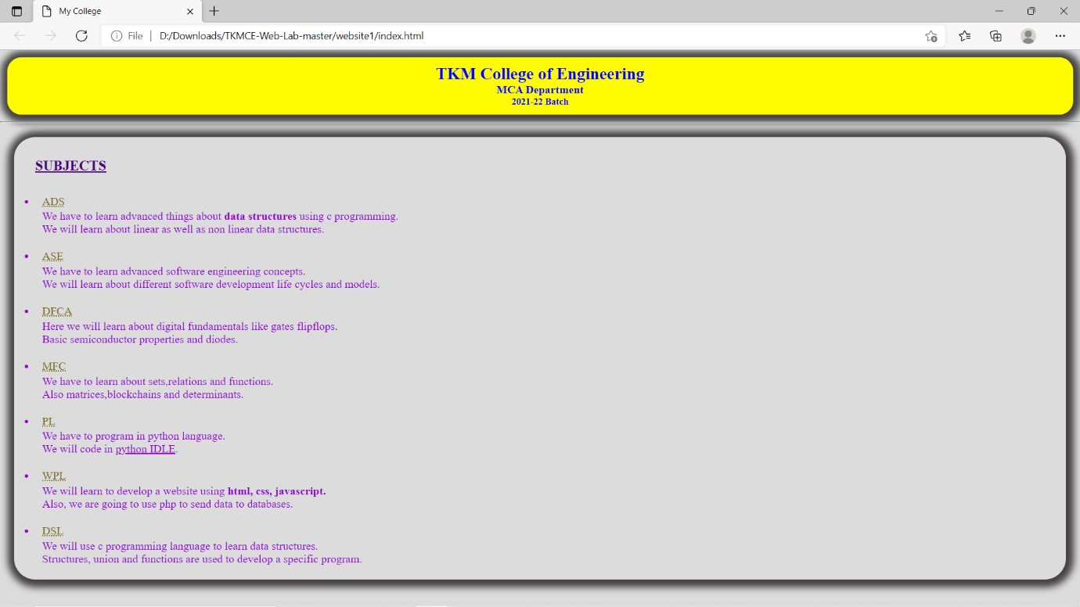

**RESULT:** The program was successfully executed and obtained the output

**PROGRAM NO: 2**

**AIM:** Create a HTML file to link to different HTML page which contains images, tables,

and also link within a page.

**DESIGN:**

1. Create an html page containing your basic information’s.

2. Create an html page containing your academic information’s.

3. Create an html page containing your contact details.

4. Create a CSS file for styling.

**SOURCE CODE:**

|  |  |
| --- | --- |
| basic_info.html | <html lang="en">  <head>  <meta charset="UTF-8">  <meta http-equiv="X-UA-Compatible" content="IE=edge">  <meta name="viewport" content="width=device-width, initial-scale=1.0">  <title>My Resume</title>  <link rel="stylesheet" href="style.css">  </head>  <body>  <!--Navbar-->  <div class="nav">  <table class="table1" border="0" width="100%" cellpadding="5">  <tr>  <td><a href="basic_info.html">Basic Info</a></td>  <td><a href="academic.html">Academic Info</a></td>  <td><a href="contact.html">Contact me</a></td>  </tr>  </table>  </div>  <!--basic info-->  <div class="basic_info">  <table class="table2" width="100%" border="0">  <tr>  <center>  <img src="arun.jpg">  </center>  </tr>  <tr colspan="2">  <td>  Basic Info<hr>  </td>  </tr>  <tr colspan="2" align="center" >  <td>Name : Arun Uday<br> Age : 22yrs</td>  </tr>  <tr colspan="2">  <td>Contact Details<hr></td>  </tr>  <tr colspan="2" align="center">  <td>Address : Arunodayam, Pampuram, Kalluvathukkal P.O, Kollam<br>  Email: arunuday117@gmail.com  </td>  </tr>  <tr colspan="2">  <td>About me <hr></td>  </tr>  <tr colspan="2" align="center">  <td>I am a MCA student @<a href="https://tkmce.ac.in/">TKM College of Engineering</a></td>  </tr>  </table>  </div>  </body>  </html> |
| academic_info.html | <html lang="en">  <head>  <meta charset="UTF-8">  <meta http-equiv="X-UA-Compatible" content="IE=edge">  <meta name="viewport" content="width=device-width, initial-scale=1.0">  <title>Academic Info</title>  <link rel="stylesheet" href="style.css">  </head>  <body>  <!--Navbar-->  <div class="nav">  <table class="table1" border="0" width="100%" cellpadding="5">  <tr>  <td><a href="basic_info.html">Basic Info</a></td>  <td><a href="academic.html">Academic Info</a></td>  <td><a href="contact.html">Contact me</a></td>  </tr>  </table>  </div>  <!--academic info-->  <div class="academic">  <table class="table3" width="100%">  <tr>  <td>Academic Details<hr></td>  </tr>  </table>  <table class="table4" width="90%" >  <tr>  <td><b>Class Programmes</b></td>  <td><b>Passing Year</b></td>  <td><b>Institution</b></td>  <td><b>Board</b></td>  <td><b>Marks</b></td>  </tr>  <tr>  <td>MCA</td>  <td>2023</td>  <td>TKM College of Engineering</td>  <td>KTU</td>  <td>pending</td>  </tr>  <tr>  <td>BCA</td>  <td>2021</td>  <td>Sree Narayana College of Technology</td>  <td>Kerala University</td>  <td>8.202</td>  </tr>  <tr>  <td>Plus Two</td>  <td>2017</td>  <td>Ezhippuram HSS</td>  <td>HSE</td>  <td>87%</td>  </tr>  </table>  </div>  </body>  </html> |
| about.html | <html lang="en">  <head>  <meta charset="UTF-8">  <meta http-equiv="X-UA-Compatible" content="IE=edge">  <meta name="viewport" content="width=device-width, initial-scale=1.0">  <title>Contact</title>  <link rel="stylesheet" href="style.css">  </head>  <body>  <div class="nav">  <table class="table1" border="0" width="100%" cellpadding="5">  <tr>  <td><a href="basic_info.html">Basic Info</a></td>  <td><a href="academic.html">Academic Info</a></td>  <td><a href="contact.html">Contact me</a></td>  </tr>  </table>  </div>  <!--about-->  <div class="about">  <table class="table5" border="0" >  <tr>  <td>Contact Me:</td><td>arunuday117@gmail.com</td>  </tr>  <tr>  <td>Github Profile:</td><td><a href="https://github.com/arunuday117/">arunuday117</a></td>  </tr>  </table>  </div>  </body>  </html> |
| style.css | body{  background-color: #edf59e;  font-family: Arial, Helvetica, sans-serif;  }  .table1{  margin-top: 10px;  padding-left: 20px;  }  a{  text-decoration: none;  display: block;  }  .table1 tr{  background-color: rgb(107, 171, 201);  text-align: center;  color: rgb(104, 48, 32);  font-size: 15px;  }  .basic_info{  padding: 20px;  }  img{  width: 20%;  }  .table3{  margin: 20px;  }  .table4{  margin-left: 20px;  margin-right: 20px;  }  .table4 ,.table4 tr,.table4 td{  border-collapse: collapse;  border: 1px solid black;  background-color: azure;  }  .about{  margin: auto;  }  table.table5 {  margin: auto;  margin-top:30px;  } |

**OUTPUT:**

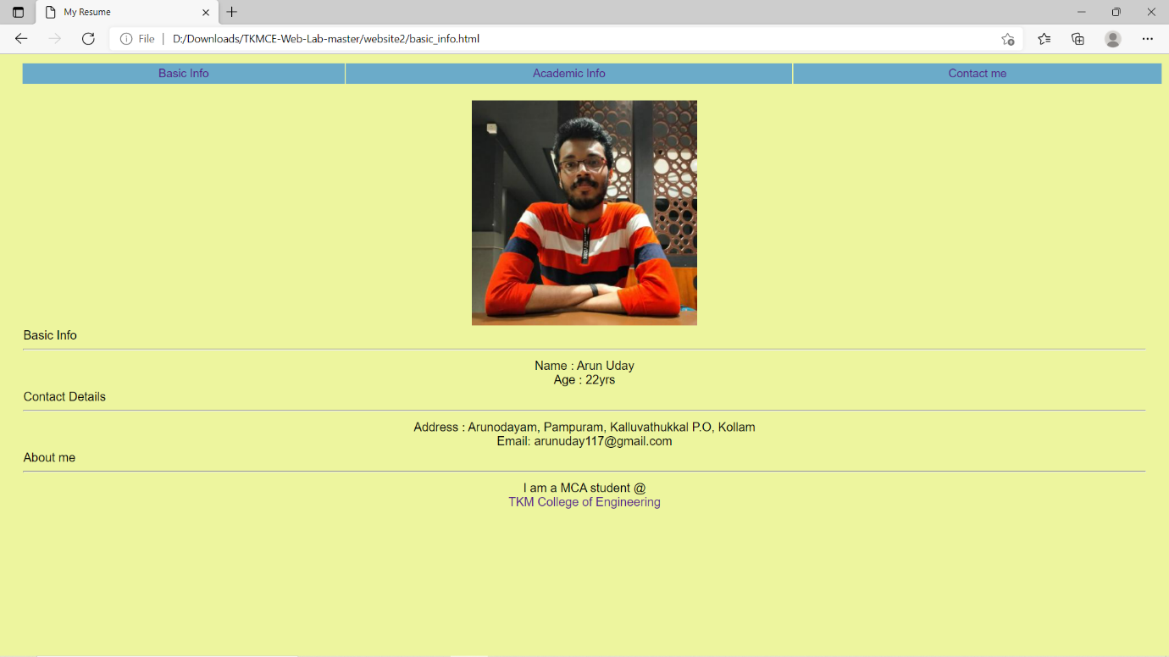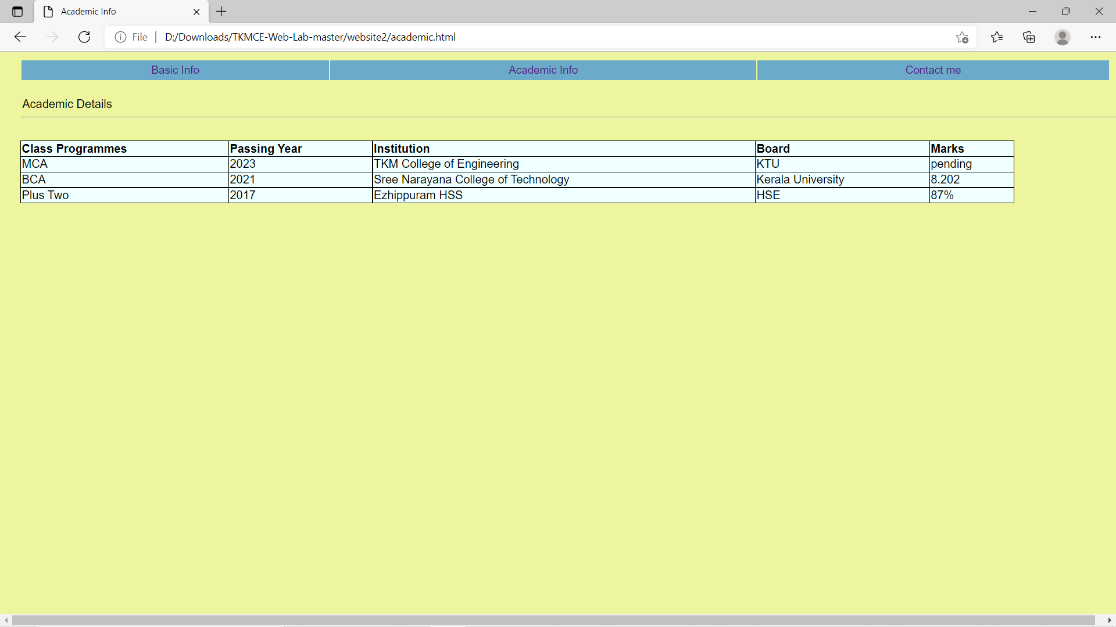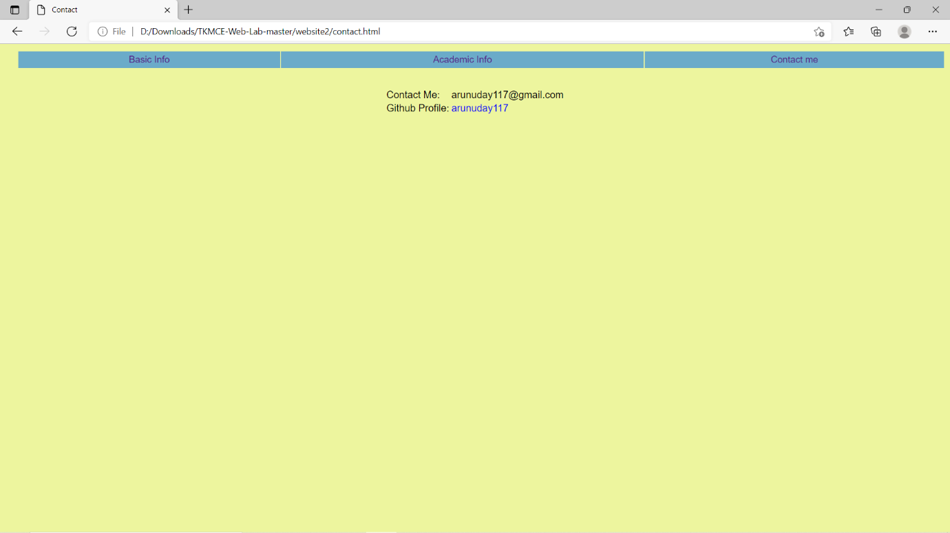

**RESULT:** The program was successfully executed and obtained the output

**PROGRAM NO: 3**

**AIM:** Create a HTML page with different types of frames such as floating frame, navigation frame & mixed frame.

**DESIGN:**

1. Create an html page containing floating frames.

2. Create an html page containing navigation frames.

3. Create an html page containing mixed frames.

4. Create a CSS file for styling.

**SOURCE CODE:**

|  |  |
| --- | --- |
| index.html | <html lang="en">  <head>  <meta charset="UTF-8">  <meta http-equiv="X-UA-Compatible" content="IE=edge">  <meta name="viewport" content="width=device-width, initial-scale=1.0">  <title>Frames</title>  </head>  <frameset cols = "20%,80%">  <frame name = "menubar" src = "menubar.html" />  <frame name = "main" src = "new_page.html" />  </frameset>  </html> |
| menubar.html | <html lang="en">  <head>  <meta charset="UTF-8">  <meta http-equiv="X-UA-Compatible" content="IE=edge">  <meta name="viewport" content="width=device-width, initial-scale=1.0">  <title>MenuBar</title>  <link rel="stylesheet" href="style.css">  </head>  <body>  <div class="navbar">  <a href="new_page.html" target="main" class="nav">Home</a>  <a href="frame.html" target="main" class="nav">Floating Frame</a>  <a href="nav_frame.html" target="main" class="nav">Navigation Frame</a>  <a href="mixed_frame.html" target="main" class="nav">Mixed Frame</a>  </div>  </body>  </html> |
| new_page.html | <html lang="en">  <head>  <meta charset="UTF-8">  <meta http-equiv="X-UA-Compatible" content="IE=edge">  <meta name="viewport" content="width=device-width, initial-scale=1.0">  <title>Page</title>  <link rel="stylesheet" href="style.css">  </head>  <body>  <div class="content">  <p>Your Content will be displayed here. </p>  </div>  </body>  </html> |
| float_frame.html | <html lang="en">  <head>  <meta charset="UTF-8">  <meta http-equiv="X-UA-Compatible" content="IE=edge">  <meta name="viewport" content="width=device-width, initial-scale=1.0">  <title>Floating Frame</title>  </head>  <iframe src="https://tkmce.ac.in/" width="40%" height="50%" loading="lazy"></iframe>  <iframe src="https://mgmschool.com/Parippally" width="40%" height="50%"></iframe>  </html> |
| nav_frame.html | <html lang="en">  <head>  <meta charset="UTF-8">  <meta http-equiv="X-UA-Compatible" content="IE=edge">  <meta name="viewport" content="width=device-width, initial-scale=1.0">  <title>Navigation Frame</title>  <link rel="stylesheet" href="style.css">  </head>  <frameset cols = "20%,80%">  <frame name = "navbar" src = "navbar.html" />  <frame name = "main" src = "new_page.html" />  </frameset>  </html> |
| navbar.html | <html lang="en">  <head>  <meta charset="UTF-8">  <meta http-equiv="X-UA-Compatible" content="IE=edge">  <meta name="viewport" content="width=device-width, initial-scale=1.0">  <title>Menu bar</title>  <link rel="stylesheet" href="style.css">  </head>  <body>  <div class="navbar">  <a href="new_page.html" target="main" class="nav">Home</a>  <a href="https://tkmce.ac.in" target="main" class="nav">TKM Collge of Engineering</a>  <a href="https://cet.ac.in" target="main" class="nav">Collge of Engineering TVM</a>  <a href="https://gectcr.ac.in/" target="main" class="nav">Goverment Engineering College Thrissur</a>  </div>  </body>  </html> |
| mixed_frame.html | <html lang="en">  <head>  <meta charset="UTF-8">  <meta http-equiv="X-UA-Compatible" content="IE=edge">  <meta name="viewport" content="width=device-width, initial-scale=1.0">  <title>Mixed Frames</title>  <link rel="stylesheet" href="style.css">  </head>  <frameset cols = "50%,50%">  <frame name = "check" src = "frame.html" />  <frame name = "check" src = "nav_frame.html" />  </frameset>  </html> |
| style.css | body{  background-color: peru;  }  a{  text-decoration: none;  font-size: 15px;  color: white;  }  .navbar{  margin:10px;  padding-top: 30px;  }  .nav{  padding-top: 30px;  display: block;  }  .nav:hover{  color: black;  }  .content{  margin-top: 50px;  color: white;  } |

**OUTPUT:**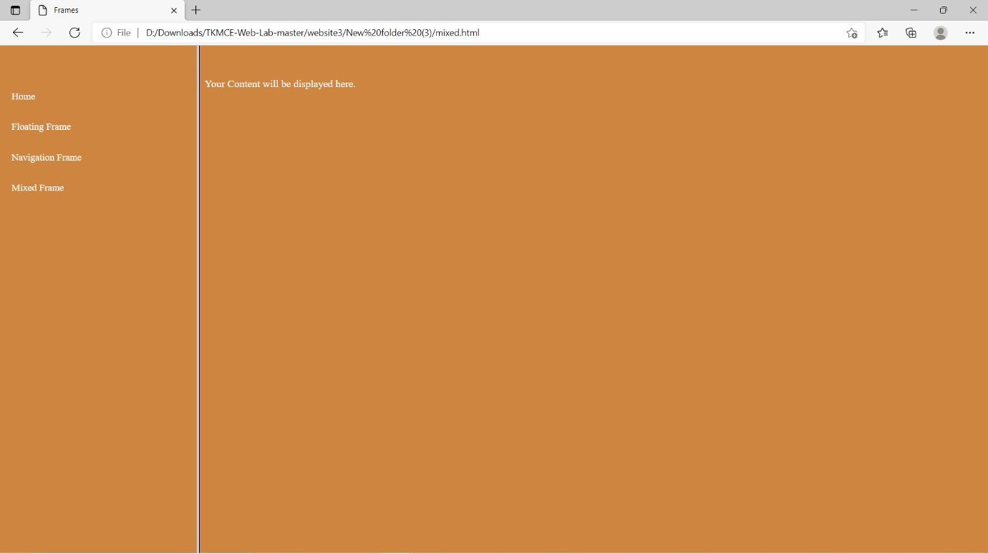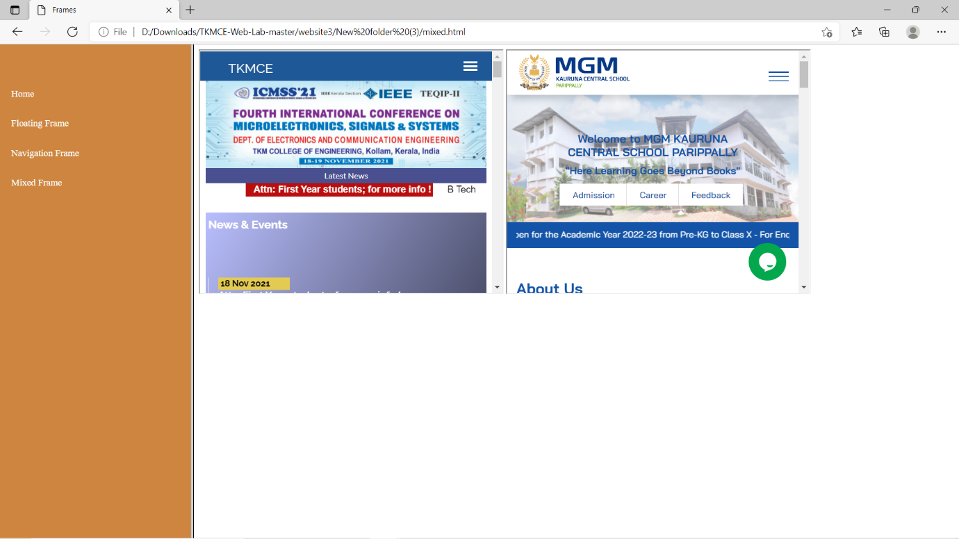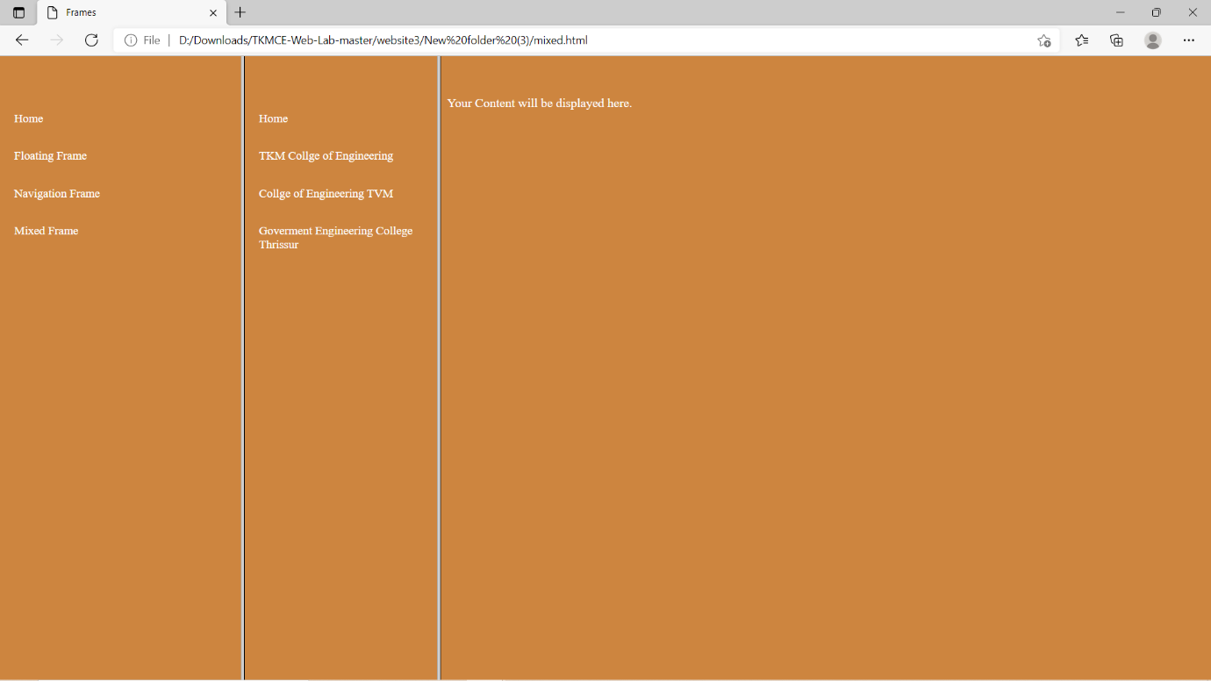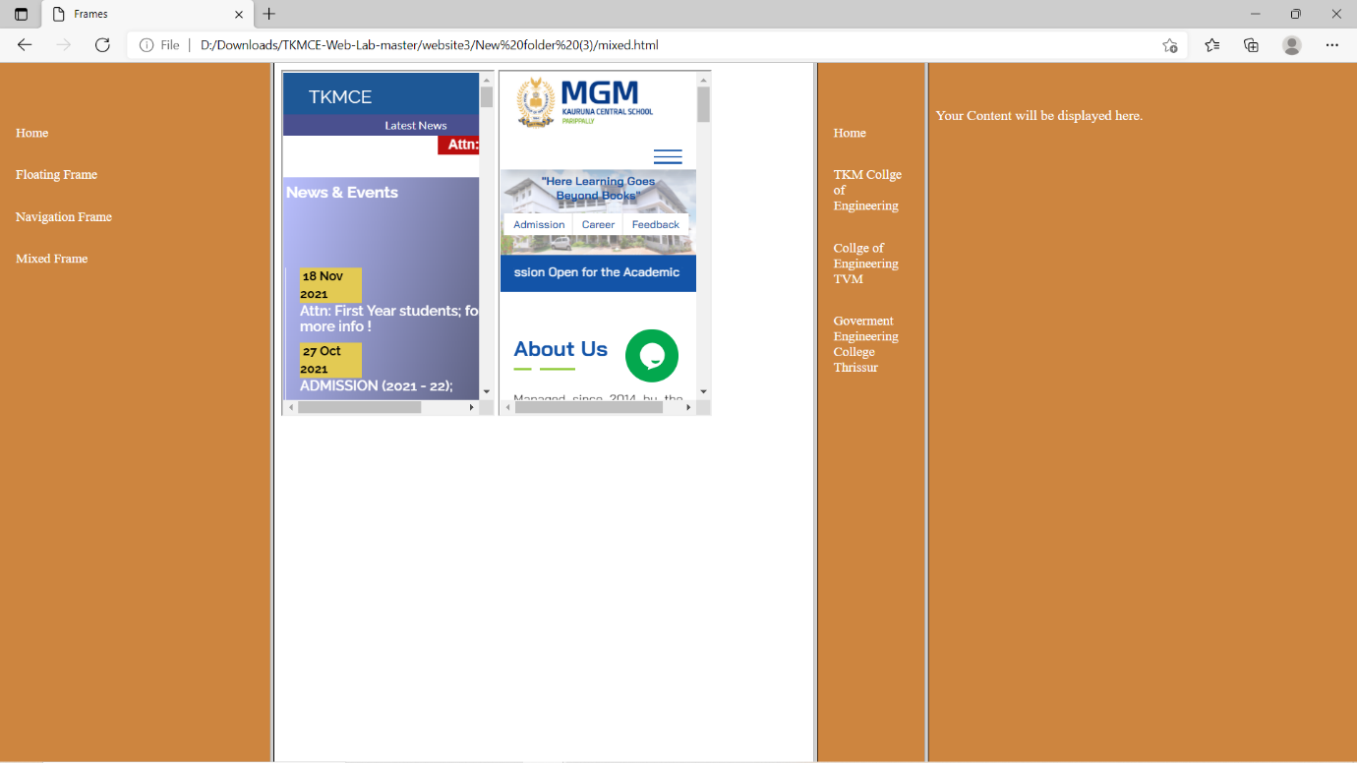

**RESULT:** The program was successfully executed and obtained the output

**PROGRAM NO: 4**

**AIM:** Analyse CSS by applying the different styles using inline, external & internal style sheets in a HTML file.

**DESIGN:**

1. Create an html page containing inline and internal CSS.

2. Create a CSS file for styling.

**SOURCE CODE:**

|  |  |
| --- | --- |
| index.html | <html lang="en">  <head>  <meta charset="UTF-8">  <meta http-equiv="X-UA-Compatible" content="IE=edge">  <meta name="viewport" content="width=device-width, initial-scale=1.0">  <title>CSS</title>  <link href="https://fonts.googleapis.com/css2?family=Poppins:wght@500&display=swap" rel="stylesheet">  <link rel="stylesheet" href="style.css">  <style>  form .input{  padding: 10px;  position: relative;  }  .input_form{  background-color: rgb(129, 147, 252,0.3);  height: 30px;  width: 200px;  border-radius: 5px;  border: none;  color: #fff;  padding: 13px;  margin-right: 10px;  }  .space{  width: 350px;  }  .input_form:hover{  background-color: rgb(123, 125, 235,0.2);  }  .input_form::placeholder{  color: #ffffffa3;  text-transform: uppercase;  }  .input label{  color: #FFF;  display: inline-block;  width:250px;  }  .input textarea{  height: 60px;  padding-top: 5px;  }  .input_form_file{  background-color: rgb(129, 147, 252,0.3);  height: 70px;  border-radius: 5px;  border: none;  color: #fff;  padding: 13px;  margin-right: 10px;  }  input[type="file"]::-webkit-file-upload-button {  color: #deeeee;  background-color: rgb(129, 147, 252,0.3);  border: none;  width: 100px;  height: 40px;  }  select.input_form_select {  height: 40px;  border-radius: 5px;  border: 1px;  background-color: #4353ac;  color: #FFF;  padding-left: 10px;  text-transform: uppercase;  }  .input span{  color: #b2bbe0;  margin-right: 10px;  }  .input button{  background: #687cd1;  border-color: #465ec0;  color: #fff;  border-radius: 40px;  padding: 11px 16px;  border-width: 1px;  font-size: 14px;  font-weight: 900;  box-shadow: 0 10px 20px -6px rgb(0 0 0 / 12%);  position: relative;  left: 50%;  transform: translate(-125%, 50%);  margin: 19px 3px;  width: 150px;  text-transform: uppercase;  }  .input button:hover{  background-color: #b2bbe0;  }  </style>  </head>  <body>  <!--form-->  <div class="form" title="External CSS">  <h2 title="Inline CSS" style="color: #FFF;transform: translate(35%, 10%);padding-bottom: 30px;font-weight: 900;">REGISTRATION FORM</h2>  <form action="" class="register" method="post" title="Internal CSS">  <div class="input">  <label>Your Full Name </label>  <input type="text" class="input_form" name="fname" placeholder="First Name" required autofocus="required" title="First name">  <input type="text" class="input_form" name="mname" placeholder="Middle Name" required title="Middle name">  <input type="text" class="input_form" name="lname" placeholder="Last Name" required title="Last name">  </div>  <div class="input">  <label>Gender </label>  <input type="radio" class="input_form_radio" name="gender" value="male" required><span>Male</span>  <input type="radio" class="input_form_radio" name="gender" value="female" ><span>Female</span>  </div>  <div class="input">  <label>Date of birth </label>  <input type="date" class="input_form space" name="dob" required placeholder="Date of Birth">  </div>  <div class="input">  <label>Email Id </label>  <input type="email" class="input_form space" name="email" required placeholder="Email Id">  </div>  <div class="input">  <label>Age </label>  <input type="number" class="input_form space" name="age" required placeholder="Age">  </div>  <div class="input">  <label>Phone No </label>  <input type="tel" class="input_form space" name="number" required placeholder="Phone No">  </div>  <div class="input">  <label>Address </label>  <textarea name="address" required style="overflow: hidden; resize: none;" class="input_form space" placeholder="Enter Your address"></textarea>  </div>  <div class="input">  <label>Nationality </label>  <select name="nationality" required class="input_form_select space">  <option selected>---Select---</option>  <option>Afganisthan</option>  <option>Algeria</option>  <option>Bermuda</option>  <option>China</option>  <option>India</option>  <option>Pakistan</option>  <option>Siberia</option>  <option>Tajakistan</option>  </select>  </div>  <div class="input">  <label>Languages Known </label>  <input type="checkbox" class="input_form_box" name="language" required><span>C</span>  <input type="checkbox" class="input_form_box" name="language"><span>C++</span>  <input type="checkbox" class="input_form_box" name="language"><span>JAVA</span>  <input type="checkbox" class="input_form_box" name="language"><span>C#</span>  <input type="checkbox" class="input_form_box" name="language"><span>Python</span>  <input type="checkbox" class="input_form_box" name="language"><span>React</span>  </div>  <div class="input">  <label>Upload Resume </label>  <input type="file" class="input_form_file space" required name="file">  </div>  <div class="input">  <label>Password </label>  <input type="password" name="password" required class="input_form space" placeholder="Password">  </div>  <div class="input">  <label>Confirm Password </label>  <input type="password" name="cpassword" required class="input_form space" placeholder="Retype Password">  </div>  <div class="input">  <button type="reset" value="reset" style="background-color: #097ec4">Reset</button>  <button type="submit" value="submit">Submit</button>  </div>  </form>  </div>  </body>  </html> |
| style.css | body{  background: url("bg.jpg");  background-repeat: no-repeat;  background-size: cover;  font-family: 'Poppins', sans-serif;  display: flex;  justify-content: center;  align-items: center;  text-transform: uppercase;  }  .form{  background-color: rgba(64, 92, 184, 0.4);  border-radius: 10px;  padding: 30px;  margin: 20px;  } |

**OUTPUT:**

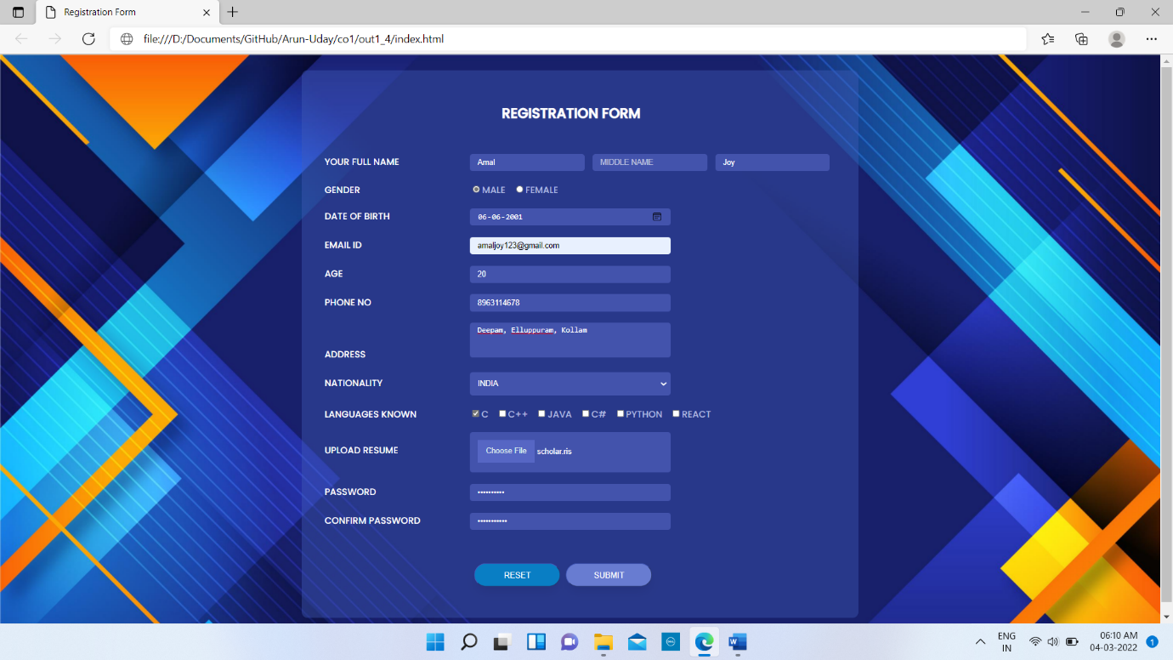

**RESULT:** The program was successfully executed and obtained the output

**PROGRAM NO: 5**

**AIM:** Demonstrate a registration form using HTML.

**DESIGN:**

1. Create an html page containing a form.

2. Create a CSS file for styling.

**SOURCE CODE:**

|  |  |
| --- | --- |
| index.html | <html lang="en">  <head>  <meta charset="UTF-8">  <meta http-equiv="X-UA-Compatible" content="IE=edge">  <meta name="viewport" content="width=device-width, initial-scale=1.0">  <title>Registration Form</title>  <link href="https://fonts.googleapis.com/css2?family=Poppins:wght@500&display=swap" rel="stylesheet">  <link rel="stylesheet" href="style.css">  <style>  form .input{  padding: 10px;  position: relative;  }  .input_form{  background-color: rgb(129, 147, 252,0.3);  height: 30px;  width: 200px;  border-radius: 5px;  border: none;  color: #fff;  padding: 13px;  margin-right: 10px;  }  .space{  width: 350px;  }  .input_form:hover{  background-color: rgb(123, 125, 235,0.2);  }  .input_form::placeholder{  color: #ffffffa3;  text-transform: uppercase;  }  .input label{  color: #FFF;  display: inline-block;  width:250px;  }  .input textarea{  height: 60px;  padding-top: 5px;  }  .input_form_file{  background-color: rgb(129, 147, 252,0.3);  height: 70px;  border-radius: 5px;  border: none;  color: #fff;  padding: 13px;  margin-right: 10px;  }  input[type="file"]::-webkit-file-upload-button {  color: #deeeee;  background-color: rgb(129, 147, 252,0.3);  border: none;  width: 100px;  height: 40px;  }  select.input_form_select {  height: 40px;  border-radius: 5px;  border: 1px;  background-color: #4353ac;  color: #FFF;  padding-left: 10px;  text-transform: uppercase;  }  .input span{  color: #b2bbe0;  margin-right: 10px;  }  .input button{  background: #687cd1;  border-color: #465ec0;  color: #fff;  border-radius: 40px;  padding: 11px 16px;  border-width: 1px;  font-size: 14px;  font-weight: 900;  box-shadow: 0 10px 20px -6px rgb(0 0 0 / 12%);  position: relative;  left: 50%;  transform: translate(-125%, 50%);  margin: 19px 3px;  width: 150px;  text-transform: uppercase;  }  .input button:hover{  background-color: #b2bbe0;  }  </style>  </head>  <body>  <!--form-->  <div class="form" title="External CSS">  <h2 title="Inline CSS" style="color: #FFF;transform: translate(35%, 10%);padding-bottom: 30px;font-weight: 900;">REGISTRATION FORM</h2>  <form action="" class="register" method="post" title="Internal CSS">  <div class="input">  <label>Your Full Name </label>  <input type="text" class="input_form" name="fname" placeholder="First Name" required autofocus="required" title="First name">  <input type="text" class="input_form" name="mname" placeholder="Middle Name" required title="Middle name">  <input type="text" class="input_form" name="lname" placeholder="Last Name" required title="Last name">  </div>  <div class="input">  <label>Gender </label>  <input type="radio" class="input_form_radio" name="gender" value="male" required><span>Male</span>  <input type="radio" class="input_form_radio" name="gender" value="female" ><span>Female</span>  </div>  <div class="input">  <label>Date of birth </label>  <input type="date" class="input_form space" name="dob" required placeholder="Date of Birth">  </div>  <div class="input">  <label>Email Id </label>  <input type="email" class="input_form space" name="email" required placeholder="Email Id">  </div>  <div class="input">  <label>Age </label>  <input type="number" class="input_form space" name="age" required placeholder="Age">  </div>  <div class="input">  <label>Phone No </label>  <input type="tel" class="input_form space" name="number" required placeholder="Phone No">  </div>  <div class="input">  <label>Address </label>  <textarea name="address" required style="overflow: hidden; resize: none;" class="input_form space" placeholder="Enter Your address"></textarea>  </div>  <div class="input">  <label>Nationality </label>  <select name="nationality" required class="input_form_select space">  <option selected>---Select---</option>  <option>Afganisthan</option>  <option>Algeria</option>  <option>Bermuda</option>  <option>China</option>  <option>India</option>  <option>Pakistan</option>  <option>Siberia</option>  <option>Tajakistan</option>  </select>  </div>  <div class="input">  <label>Languages Known </label>  <input type="checkbox" class="input_form_box" name="language" required><span>C</span>  <input type="checkbox" class="input_form_box" name="language"><span>C++</span>  <input type="checkbox" class="input_form_box" name="language"><span>JAVA</span>  <input type="checkbox" class="input_form_box" name="language"><span>C#</span>  <input type="checkbox" class="input_form_box" name="language"><span>Python</span>  <input type="checkbox" class="input_form_box" name="language"><span>React</span>  </div>  <div class="input">  <label>Upload Resume </label>  <input type="file" class="input_form_file space" required name="file">  </div>  <div class="input">  <label>Password </label>  <input type="password" name="password" required class="input_form space" placeholder="Password">  </div>  <div class="input">  <label>Confirm Password </label>  <input type="password" name="cpassword" required class="input_form space" placeholder="Retype Password">  </div>  <div class="input">  <button type="reset" value="reset" style="background-color: #097ec4">Reset</button>  <button type="submit" value="submit">Submit</button>  </div>  </form>  </div>  </body>  </html> |
| style.css | body{  background: url("bg.jpg");  background-repeat: no-repeat;  background-size: cover;  font-family: 'Poppins', sans-serif;  display: flex;  justify-content: center;  align-items: center;  text-transform: uppercase;  }  .form{  background-color: rgba(64, 92, 184, 0.4);  border-radius: 10px;  padding: 30px;  margin: 20px;  } |

**OUTPUT:**

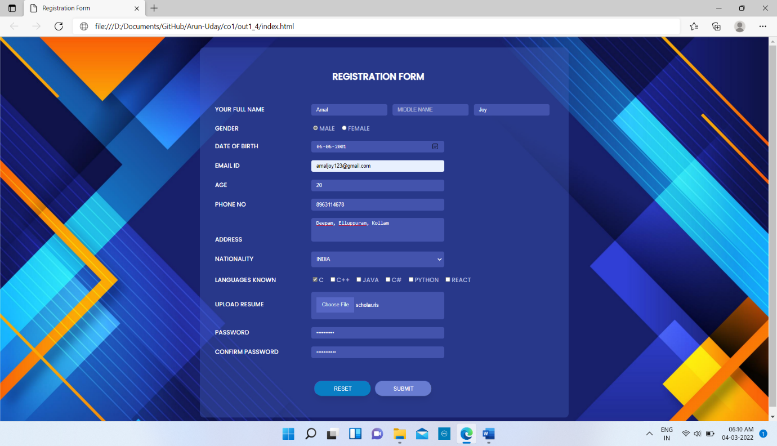

**RESULT:** The program was successfully executed and obtained the output

**JAVASCRIPT**

JavaScript often abbreviated JS, is a programming language that is one of the core technologies of the World Wide Web, alongside HTML and CSS. Over 97% of websites use JavaScript on the client side for web page behaviour, often incorporating third-party libraries. All major web browsers have a dedicated JavaScript engine to execute the code on users' devices.

JavaScript is a high-level, often just-in-time compiled language that conforms to the ECMAScript standard. It has dynamic typing, prototype-based object-orientation, and first-class functions. It is multi-paradigm, supporting event-driven, functional, and imperative programming styles. It has application programming interfaces (APIs) for working with text, dates, regular expressions, standard data structures, and the Document Object Model (DOM).

The ECMAScript standard does not include any input/output (I/O), such as networking, storage, or graphics facilities. In practice, the web browser or other runtime system provides JavaScript APIs for I/O.

JavaScript engines were originally used only in web browsers, but are now core components of some servers and a variety of applications. The most popular runtime system for this usage is Node.js.

Although Java and JavaScript are similar in name, syntax, and respective standard libraries, the two languages are distinct and differ greatly in design.

**PROGRAM NO: 6**

**AIM:** Create a HTML page to explain the use of various predefined functions in a string and math object in java script

**DESIGN:**

1. Create an HTML page containing string functions
2. Create an HTML page containing math functions

**SOURCE CODE:**

|  |  |
| --- | --- |
| index.html | <html lang="en">  <head>  <meta charset="UTF-8">  <meta http-equiv="X-UA-Compatible" content="IE=edge">  <meta name="viewport" content="width=device-width, initial-scale=1.0">  <title>Outcome2 Pg1</title>  <style>  .nav{  list-style: none;  display: inline-block;  margin-left: 40px;  background-color: rgb(81, 81, 82);  padding: 20px;  }  a{  text-decoration: none;  color: #FFF;  }  </style>  </head>  <body>  <!--calculator-->  <div class="container" style="text-align: center;">  <div class="form">  <li class="nav"><a href="oc2_pg1.html">String Functions</a></li>  <li class="nav"><a href="oc2_pg1_math.html">Math Functions</a></li>  <h3>String Functions</h3>  <center>  <div class="string">  <table style="border: 1px solid black;">  <tr>  <td>Enter a string</td>  <td></td>  <td><input type="text" name="in1" id="in1"></td>  </tr>  <tr>  <td>Search a string</td>  <td></td>  <td><input type="text" name="in2" id="in2"></td>  </tr>  <tr>  <td>Slice a string</td>  <td></td>  <td><input type="number" name="in3" id="in3" placeholder="Start">  <input type="number" name="in4" id="in4" placeholder="Stop"></td>  </tr>  <tr>  <td>Replace a string</td>  <td></td>  <td><input type="text" name="in5" id="in5" placeholder="Enter the string to be replaced">  <input type="text" name="in6" id="in6" placeholder="Enter the string"></td>  </tr>  <tr>  <td>Enter a Uppercase string</td>  <td></td>  <td><input type="text" name="in7" id="in7" placeholder="Enter the string"></td>  </tr>  <tr>  <td>Enter a string concat</td>  <td></td>  <td><input type="text" name="in8" id="in8" placeholder="Enter the string"></td>  </tr>  <tr>  <td>Enter a string to pad</td>  <td></td>  <td><input type="text" name="in9" id="in9" placeholder="Enter the string"></td>  </tr>  <tr>  <td>Enter the position to find the character</td>  <td></td>  <td><input type="number" name="in10" id="in10" placeholder="Enter the position"></td>  </tr>  <tr>  <td><button type="submit" id="con" onclick="submit()">Submit</button></td>  </tr>  </table><br>  <table width="43%" style="background-color: lightslategrey; color: #FFF;">  <tr>  <td>Length of the string : </td>  <td><span id="out1"></span></td>  </tr>  <tr>  <td>Index of the string : </td>  <td><span id="out2"></span></td>  </tr>  <tr>  <td>Slice of the string : </td>  <td><span id="out3"></span></td>  </tr>  <tr>  <td>Substr of the string : </td>  <td><span id="out4"></span></td>  </tr>  <tr>  <td>Substring of the string : </td>  <td><span id="out5"></span></td>  </tr>  <tr>  <td>Replaced string : </td>  <td><span id="out6"></span></td>  </tr>  <tr>  <td>Uppercase of string : </td>  <td><span id="out7"></span></td>  </tr>  <tr>  <td>Lowercase string : </td>  <td><span id="out8"></span></td>  </tr>  <tr>  <td>Concatenated string : </td>  <td><span id="out9"></span></td>  </tr>  <tr>  <td>Padding at begining of string : </td>  <td><span id="out10"></span></td>  </tr>  <tr>  <td>Padding at end of string : </td>  <td><span id="out11"></span></td>  </tr>  <tr>  <td>Character at the position : </td>  <td><span id="out12"></span></td>  </tr>  </table>  </div>  </center>  </div>  </div>  <script>  function submit(){  var in1=document.getElementById("in1").value;  var in2=document.getElementById("in2").value;  var in3=document.getElementById("in3").value;  var in4=document.getElementById("in4").value;  var in5=document.getElementById("in5").value;  var in6=document.getElementById("in6").value;  var in7=document.getElementById("in7").value;  var in8=document.getElementById("in8").value;  var in9=document.getElementById("in9").value;  var in10=document.getElementById("in10").value;  out1=in1.length;  document.getElementById("out1").innerHTML=out1;  out2=in1.indexOf(in2);  document.getElementById("out2").innerHTML=out2;  out3=in1.slice(in3,in4);  document.getElementById("out3").innerHTML=out3;  out4=in1.substr(in3,in4);  document.getElementById("out4").innerHTML=out4;  out5=in1.substring(in3,in4);  document.getElementById("out5").innerHTML=out5;  out6=in1.replace(in5,in6);  document.getElementById("out6").innerHTML=out6;  document.getElementById("out7").innerHTML=in1.toUpperCase();  document.getElementById("out8").innerHTML=in7.toLowerCase();  document.getElementById("out9").innerHTML=in1.concat(" ",in8);  out7=in1.padStart(30,in9);  document.getElementById("out10").innerHTML=out7;  out8=in1.padEnd(30,in9);  document.getElementById("out11").innerHTML=out8;  out9=in1.charAt(in10);  document.getElementById("out12").innerHTML=out9;  }  </script>  </body>  </html> |
| math.html | <html lang="en">  <head>  <meta charset="UTF-8">  <meta http-equiv="X-UA-Compatible" content="IE=edge">  <meta name="viewport" content="width=device-width, initial-scale=1.0">  <title>math</title>  <style>  .nav{  list-style: none;  display: inline-block;  margin-left: 40px;  background-color: rgb(81, 81, 82);  padding: 20px;  }  a{  text-decoration: none;  color: #FFF;  }  </style>  </head>  <body>  <div class="container" style="text-align: center;">  <div class="form">  <li class="nav"><a href="oc2_pg1.html">String Functions</a></li>  <li class="nav"><a href="oc2_pg1_math.html">Math Functions</a></li>  <h3>Math Functions</h3>  <center>  <div class="string">  <table style="border: 1px solid black;" width="43%">  <tr>  <td>Enter a number</td>  <td></td>  <td><input type="number" name="in1" id="in1"></td>  </tr>  <tr>  <td>Enter a decimal number</td>  <td></td>  <td><input type="number" name="in2" id="in2"></td>  </tr>  <tr>  <td>Enter a power</td>  <td></td>  <td><input type="number" name="in3" id="in3"></td>  </tr>  <tr>  <td>Enter a degree</td>  <td></td>  <td><input type="number" name="in4" id="in4"></td>  </tr>    <tr>  <td><button type="submit" id="con" onclick="submit()">Submit</button></td>  </tr>  </table><br>  <table width="43%" style="background-color: lightslategrey; color: #FFF;">  <tr>  <td>Area of a circle using math.pi : </td>  <td><span id="out1"></span></td>  </tr>  <tr>  <td>Square root using math.sqrt : </td>  <td><span id="out2"></span></td>  </tr>  <tr>  <td>Rounded number using math.round : </td>  <td><span id="out3"></span></td>  </tr>  <tr>  <td>Rounded number using math.ceil : </td>  <td><span id="out4"></span></td>  </tr>  <tr>  <td>Rounded number using math.floor : </td>  <td><span id="out5"></span></td>  </tr>  <tr>  <td>Rounded number using math.trunc : </td>  <td><span id="out6"></span></td>  </tr>  <tr>  <td>Absolute value using math.abs : </td>  <td><span id="out7"></span></td>  </tr>  <tr>  <td>Find sign using math.sign : </td>  <td><span id="out8"></span></td>  </tr>  <tr>  <td>Power using math.pow : </td>  <td><span id="out9"></span></td>  </tr>  <tr>  <td>Sin using math.sin : </td>  <td><span id="out10"></span></td>  </tr>  <tr>  <td>Cos using math.cos : </td>  <td><span id="out11"></span></td>  </tr>  <tr>  <td>Max value using math.max : </td>  <td><span id="out12"></span></td>  </tr>  <tr>  <td>Min value using math.min : </td>  <td><span id="out13"></span></td>  </tr>  <tr>  <td>Random value using math.random : </td>  <td><span id="out14"></span></td>  </tr>  <tr>  <td>Log using math.log : </td>  <td><span id="out15"></span></td>  </tr>  </table>  </div>  </center>  </div>  </div>  <script>  function submit(){  var in1=document.getElementById("in1").value;  var in2=document.getElementById("in2").value;  var in3=document.getElementById("in3").value;  var in4=document.getElementById("in4").value;  document.getElementById("out1").innerHTML=Math.PI*in1*in1;  document.getElementById("out2").innerHTML=Math.sqrt(in1);  document.getElementById("out3").innerHTML=Math.round(in2);  document.getElementById("out4").innerHTML=Math.ceil(in2);  document.getElementById("out5").innerHTML=Math.floor(in2);  document.getElementById("out6").innerHTML=Math.trunc(in2);  document.getElementById("out7").innerHTML=Math.abs(in2);  document.getElementById("out8").innerHTML=Math.sign(in2);  document.getElementById("out9").innerHTML=Math.pow(in1,in3);  document.getElementById("out10").innerHTML=Math.sin(in4*Math.PI/180);  document.getElementById("out11").innerHTML=Math.cos(in4*Math.PI/180);  document.getElementById("out12").innerHTML=Math.max(in1,in2);  document.getElementById("out13").innerHTML=Math.min(in1,in2);  document.getElementById("out14").innerHTML=Math.random();  document.getElementById("out15").innerHTML=Math.log(in1);  }  </script>  </body>  </html> |

**OUTPUT:**

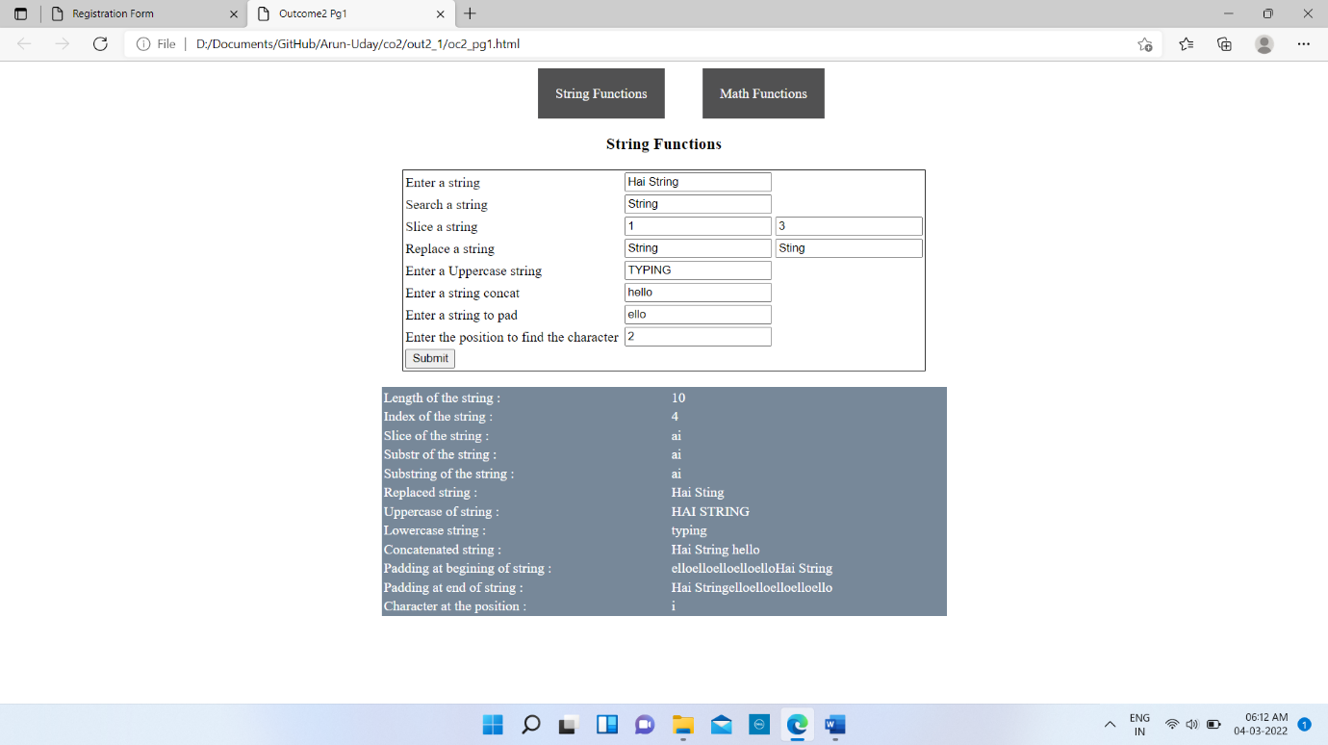

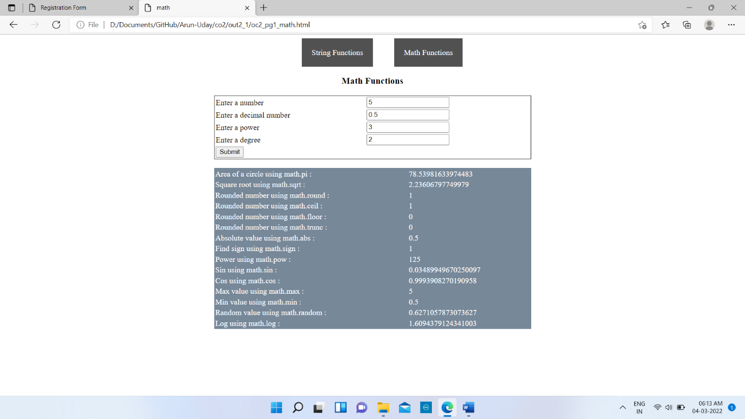

**RESULT:** The program was successfully executed and obtained the output

**PROGRAM NO: 7**

**AIM:** Generate the calendar using JavaScript code by getting the year from the user

**DESIGN:** Create an HTML page for displaying calendar

**SOURCE CODE:**

|  |  |
| --- | --- |
| index.html | <!DOCTYPE html>  <html lang="en">  <head>  <meta charset="UTF-8">  <meta http-equiv="X-UA-Compatible" content="IE=edge">  <meta name="viewport" content="width=device-width, initial-scale=1.0">  <title>CALENDAR</title>  <style>  table {  border-collapse: collapse;  }  td,  th {  border: 1px solid black;  padding: 3px;  text-align: center;  }  th {  font-weight: bold;  background-color: #E6E6E6;  }  .container{  display:none;  }  </style>  </head>  <body>  <div class="inputs">  <label class="enter">Enter the year</label>  <input type="tel" name="input" id="input">  <input type="hidden" name="hidden" id="hidden">  <input type="button" value="View" onclick="cal()" id="submit">  </div>  <div class="container">  <div class="calendar">  <div class="month">  <div class="date">  <h3 class="months" id="years"></h3>  <h3 class="months" id="months"></h3>  <p class="year" id="year"></p>  </div>  </div>  <div id="days"></div>  <a href="#" id="prev">Previous</a>  <a href="#" id="next">Next</a>  </div>  </div>  <script>  function cal(){  document.querySelector('.container');  var s = document.getElementById('input').value;  var d = new Date(s);  var num=0;  var n=0,j=0;  var arr=[6,13,20,27,34];  var months = ["January", "February", "March", "April", "May", "June", "July", "August", "September", "October", "November", "December"];  document.getElementById('years').innerHTML=d.getFullYear();  document.getElementById('months').innerHTML='<h3>'+months[d.getMonth()]+'</h3>';  document.getElementById('year').innerHTML=new Date().toDateString();  var final=new Date(d.getFullYear(),d.getMonth()+1,0).getDate();  var firstDay=d.getDay();  var lastDay=new Date(d.getFullYear(),d.getMonth()+1,0).getDay();  document.getElementById('hidden').value=d;  var td='<table border="1" width="50%"><tr><th>SUN</th><th>MON</th><th>TUE</th><th>WED</th><th>THUR</th><th>FRI</th><th>SAT</th></tr><tr>';  for(var i=firstDay;i>0;i--){  td+=`<td></td>`;  num++;  }  for(var i=1;i<=final;i++){  if((num%6)==n && num==arr[j]){  td += '<td>'+i+'</td>';  td +='</tr><tr>';  n++;  j++;  }  else{  td += `<td>${i}</td>`;  }  num++;  }  for(var i=lastDay;i<6;i++){  td+=`<td></td>`;  }  td+=`</tr></table>`;  days.innerHTML=td;  document.querySelector('.container').style.display="block";  }  document.querySelector('#prev').addEventListener('click',()=>{  d=document.getElementById('hidden').value;  d= new Date(d);  d.setMonth(d.getMonth()-1);  ne(d);  });  document.querySelector('#next').addEventListener('click',()=>{  d=document.getElementById('hidden').value;  d= new Date(d);  d.setMonth(d.getMonth()+1);  ne(d);  });  function ne(d){  var num=0;  var n=0,j=0;  var arr=[6,13,20,27,34];  var months = ["January", "February", "March", "April", "May", "June", "July", "August", "September", "October", "November", "December"];  document.getElementById('years').innerHTML=d.getFullYear();  document.getElementById('months').innerHTML='<h3>'+months[d.getMonth()]+'</h3>';  document.getElementById('year').innerHTML=new Date().toDateString();  var final=new Date(d.getFullYear(),d.getMonth()+1,0).getDate();  var firstDay=d.getDay();  var lastDay=new Date(d.getFullYear(),d.getMonth()+1,0).getDay();  document.getElementById('hidden').value=d;  var td='<table border="1" width="50%"><tr><th>SUN</th><th>MON</th><th>TUE</th><th>WED</th><th>THUR</th><th>FRI</th><th>SAT</th></tr><tr>';  for(var i=firstDay;i>0;i--){  td+=`<td></td>`;  num++;  }  for(var i=1;i<=final;i++){  if((num%6)==n && num==arr[j]){  td += '<td>'+i+'</td>';  td +='</tr><tr>';  n++;  j++;  }  else{  td += `<td>${i}</td>`;  }  num++;  }  for(var i=lastDay;i<6;i++){  td+=`<td></td>`;  }  td+=`</tr></table>`;  days.innerHTML=td;  }  </script>  </body>  </html> |

**OUTPUT:**

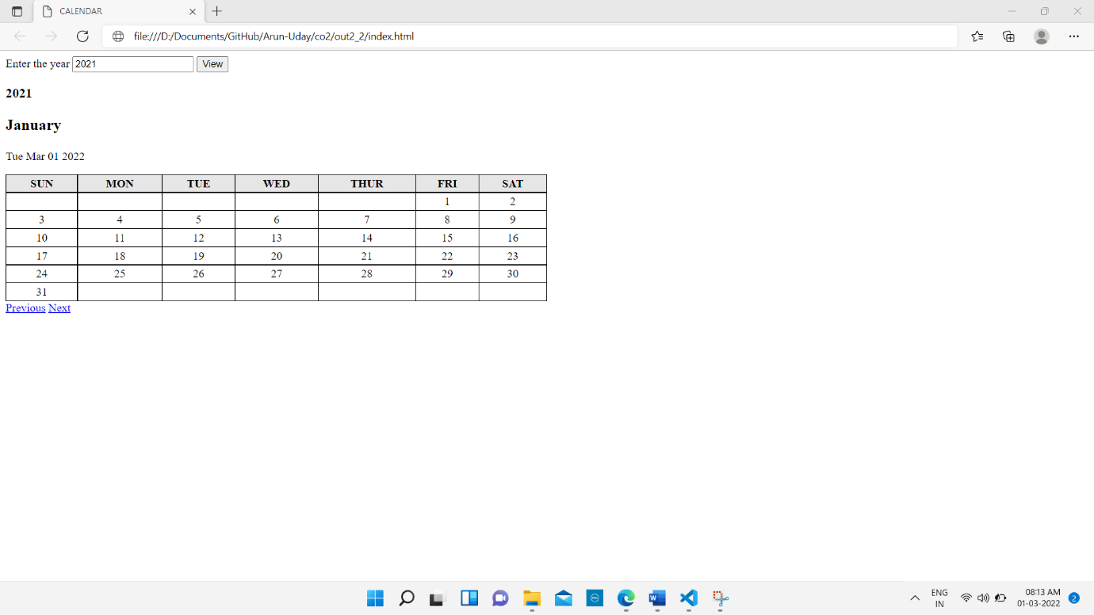

**RESULT:** The program was successfully executed and obtained the output

**PROGRAM NO: 8**

**AIM:** Create a HTML registration form and to validate the form using JavaScript code

**DESIGN:**

1. Create an HTML form

2. Add validations to the form using JavaScript

3. Use CSS to style the page

**SOURCE CODE:**

|  |  |
| --- | --- |
| index.html | <html lang="en">  <head>  <meta charset="UTF-8">  <meta http-equiv="X-UA-Compatible" content="IE=edge">  <meta name="viewport" content="width=device-width, initial-scale=1.0">  <title>Registration Form</title>  <link href="https://fonts.googleapis.com/css2?family=Poppins:wght@500&display=swap" rel="stylesheet">  <style>  body{  background: url("bg.jpg");  background-repeat: no-repeat;  background-size: cover;  font-family: 'Poppins', sans-serif;  display: flex;  justify-content: center;  align-items: center;  text-transform: uppercase;  }  .form{  background-color: rgba(64, 92, 184, 0.4);  border-radius: 10px;  padding: 30px;  margin: 20px;  }  form .input{  padding: 10px;  position: relative;  }  .input_form{  background-color: rgb(129, 147, 252,0.3);  height: 30px;  width: 200px;  border-radius: 5px;  border: none;  color: #fff;  padding: 13px;  margin-right: 10px;  }  .space{  width: 350px;  }  .input_form:hover{  background-color: rgb(123, 125, 235,0.2);  }  .input_form::placeholder{  color: #ffffffa3;  text-transform: uppercase;  }  .input label{  color: #FFF;  display: inline-block;  width:250px;  }  .input textarea{  height: 60px;  padding-top: 5px;  }  .input_form_file{  background-color: rgb(129, 147, 252,0.3);  height: 70px;  border-radius: 5px;  border: none;  color: #fff;  padding: 13px;  margin-right: 10px;  }  input[type="file"]::-webkit-file-upload-button {  color: #deeeee;  background-color: rgb(129, 147, 252,0.3);  border: none;  width: 100px;  height: 40px;  }  select.input_form_select {  height: 40px;  border-radius: 5px;  border: 1px;  background-color: #4353ac;  color: #FFF;  padding-left: 10px;  text-transform: uppercase;  }  .input span{  color: #b2bbe0;  margin-right: 10px;  }  .input button{  background: #687cd1;  border-color: #465ec0;  color: #fff;  border-radius: 40px;  padding: 11px 16px;  border-width: 1px;  font-size: 14px;  font-weight: 900;  box-shadow: 0 10px 20px -6px rgb(0 0 0 / 12%);  position: relative;  left: 50%;  transform: translate(-125%, 50%);  margin: 19px 3px;  width: 150px;  text-transform: uppercase;  }  .input button:hover{  background-color: #b2bbe0;  }  </style>  </head>  <body>  <!--form-->  <div class="form" title="External CSS">  <h2 title="Inline CSS" style="color: #FFF;transform: translate(35%, 10%);padding-bottom: 30px;font-weight: 900;">REGISTRATION FORM</h2>  <form action="" onsubmit="validate()" class="register" method="post" title="Internal CSS" name="reg_form">  <div class="input">  <label>Your Full Name </label>  <input type="text" class="input_form" name="fname" placeholder="First Name" autofocus="required" title="First name">  <input type="text" class="input_form" name="mname" placeholder="Middle Name" title="Middle name">  <input type="text" class="input_form" name="lname" placeholder="Last Name" title="Last name">  <span id="in_name"></span>  </div>  <div class="input">  <label>Gender </label>  <input type="radio" class="input_form_radio" name="gender" value="male" ><span>Male</span>  <input type="radio" class="input_form_radio" name="gender" value="female" ><span>Female</span>  <span id="in_gender"></span>  </div>  <div class="input">  <label>Email Id </label>  <input type="text" class="input_form space" name="email" placeholder="Email Id">  <span id="in_id"></span>  </div>  <div class="input">  <label>Phone No </label>  <input type="tel" class="input_form space" name="number" placeholder="Phone No">  <span id="in_ph"></span>  </div>  <div class="input">  <label>Address </label>  <textarea name="address" style="overflow: hidden; resize: none;" class="input_form space" placeholder="Enter Your address"></textarea>  <span id="in_add"></span>  </div>  <div class="input">  <label>Password </label>  <input type="password" name="password" class="input_form space" placeholder="Password">  <span id="in_pass"></span>  </div>  <div class="input">  <label>Confirm Password </label>  <input type="password" name="cpassword" class="input_form space" placeholder="Retype Password">  <span id="in_conf"></span>  </div>  <div class="input">  <button type="reset" value="reset" style="background-color: #097ec4">Reset</button>  <button type="submit" value="submit">Submit</button>  </div>  </form>  </div>  <script>  function validate(){  var fname=document.reg_form.fname;  var dob=document.reg_form.dob;  var email=document.reg_form.email;  var number=document.reg_form.number;  var password=document.reg_form.password;  if (!fname.value.match(/^[A-z ]+$/)) {  alert('*Invalid Name');  }  if (!email.value.match(/^\S+@\S+\.\S+$/)) {  alert('*Invalid Email ID');  }  if (number.value.length!=10) {  alert('*Phone number is required');  }  if (password.value.match(/^[A-Za-z]\w{7,14}$/)) {  alert('*Password is required');  }  }  </script>  </body>  </html> |

**OUTPUT:**

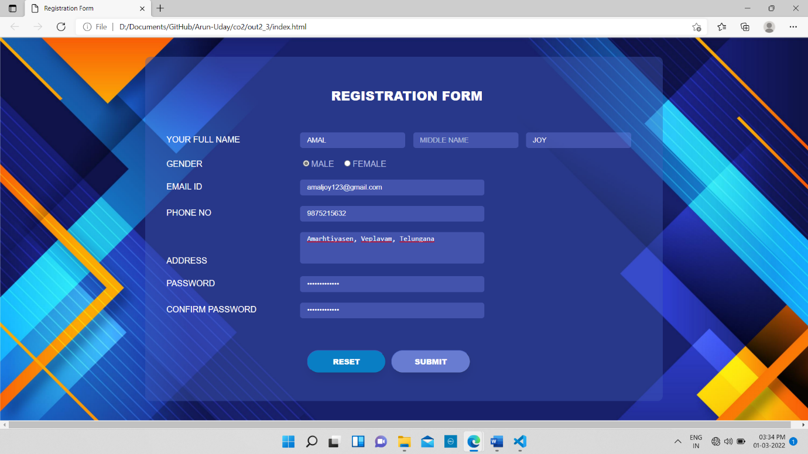

**RESULT:** The program was successfully executed and obtained the output

**PROGRAM NO: 9**

**AIM:** Evaluating JavaScript Event Handling for every click of a button to change the background color of a HTML page

**DESIGN:**

1. Create an HTML page with a button
2. Use JavaScript for change background colour

**SOURCE CODE:**

|  |  |
| --- | --- |
| index.html | <!DOCTYPE html>  <html lang="en">  <head>  <meta charset="UTF-8">  <meta http-equiv="X-UA-Compatible" content="IE=edge">  <meta name="viewport" content="width=device-width, initial-scale=1.0">  <title>Click Button</title>  </head>  <body>  <div class="container">  <h3 class="heading">Click the button to change the background color</h3>  <button type="submit" id="submit" onclick="chage();">Click Me</button>  </div>  <script>  function chage(){  var randomColor = Math.floor(Math.random()*16777215).toString(16);  document.body.style.background = '#'+randomColor;  }  </script>  </body>  </html> |

**OUTPUT:**

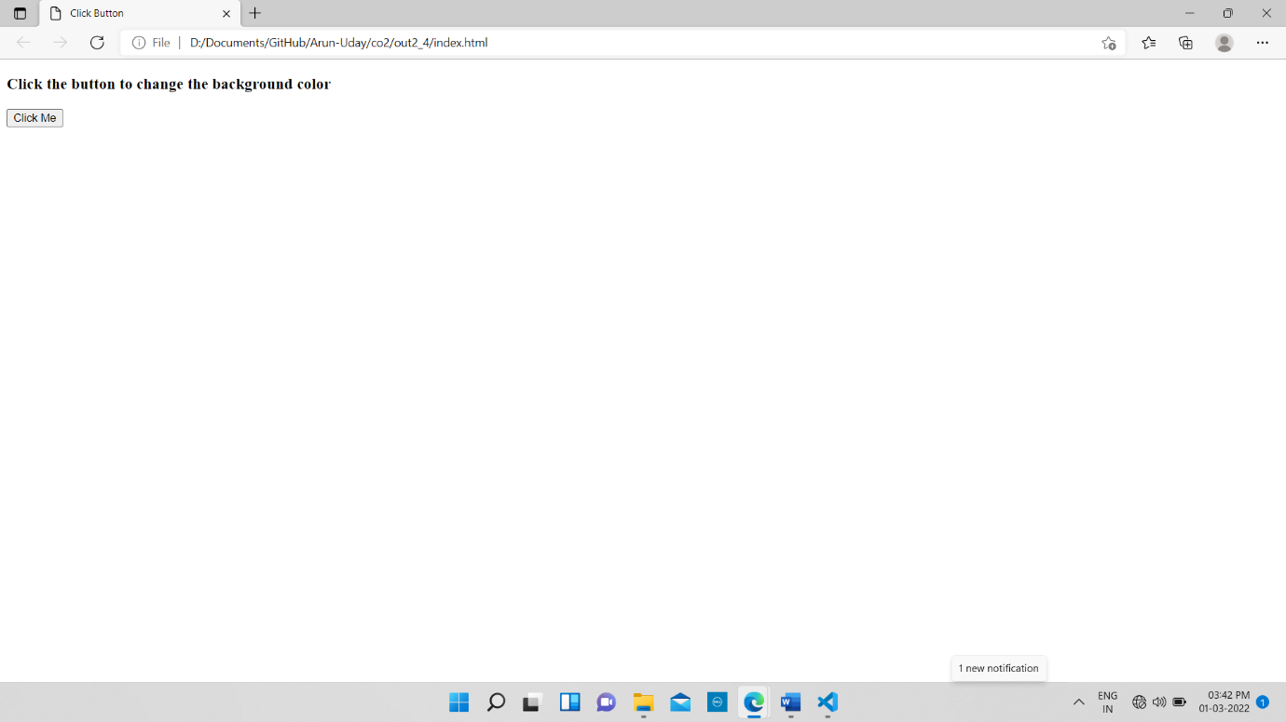

**RESULT:** The program was successfully executed and obtained the output

**PROGRAM NO: 10**

**AIM:** Create a HTML page to display a new image and text when the mouse comes over the existing content in the page using JavaScript Event Handling

**DESIGN:**

1. Create an HTML page containing an image and a text
2. Use JavaScript to change to content

**SOURCE CODE:**

|  |  |
| --- | --- |
| index.html | <!DOCTYPE html>  <html lang="en">  <head>  <meta charset="UTF-8">  <meta http-equiv="X-UA-Compatible" content="IE=edge">  <meta name="viewport" content="width=device-width, initial-scale=1.0">  <title>Document</title>  </head>  <body>  <div class="container" onmouseover="change()" onmouseout="norm()" id="hang" width="100px" height="100px">  <img src="back.jpg" width="500px"height="500px">  <h3>Hower to change the content</h3>  </div>  <script>  function change(){  var im=`<img src='bg.jpg' width="500px"height="500px">`;  var h=`<h3>Hower back to change the content</h3>`  hang.innerHTML=im+h;  }  function norm(){  var im=`<img src="back.jpg" width="500px"height="500px">`;  var h=`<h3>Hower to change the content</h3>`  hang.innerHTML=im+h;  }  </script>  </body>  </html> |

**OUTPUT:**

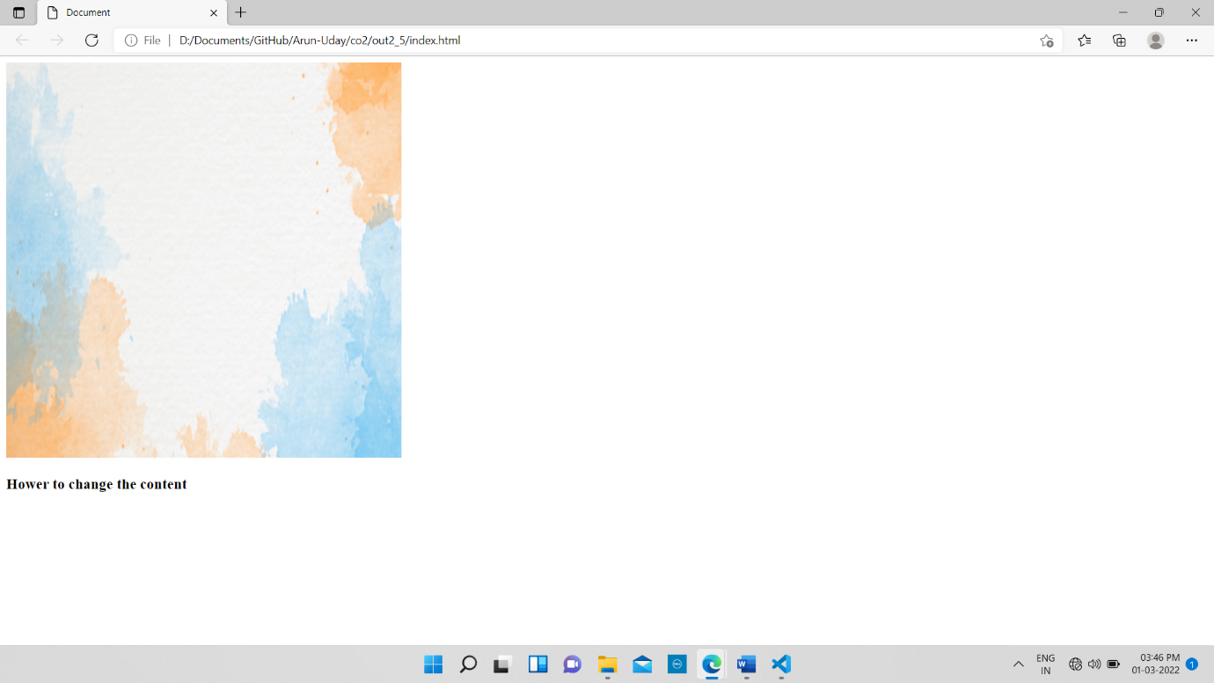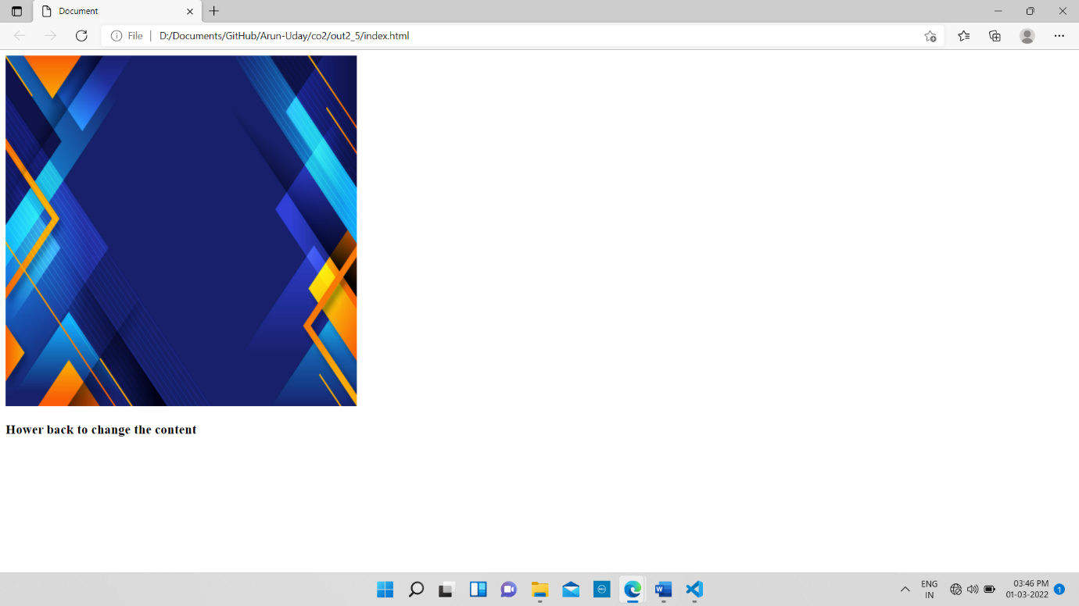

**RESULT:** The program was successfully executed and obtained the output

**PROGRAM NO: 11**

**AIM:** Create a HTML page to show online exam using JavaScript

**DESIGN:**

1. Create an HTML page containing questions
2. Use JavaScript for validation

**SOURCE CODE:**

|  |  |
| --- | --- |
| index.html | <!DOCTYPE html>  <html lang="en">  <head>  <meta charset="UTF-8">  <meta http-equiv="X-UA-Compatible" content="IE=edge">  <meta name="viewport" content="width=device-width, initial-scale=1.0">  <title>Online Exam</title>  </head>  <body>  <div class="container">  <h3>Online Examination</h3>  <p>Each question carries one mark</p>  <form action="" name="exam" >  <p>Question 1 : Multiply 2*3</p>  <p><input type="radio" name="question1" id="1" value="6">A.6</p>  <p><input type="radio" name="question1" id="2" value="5">B.5</p>  <p><input type="radio" name="question1" id="3" value="2">C.2</p>  <p><input type="radio" name="question1" id="4" value="7">D.7</p>  <p>Question 2 : Compute sin 30 degrees</p>  <p><input type="radio" name="question2" id="5" value="0.1">A.0.1</p>  <p><input type="radio" name="question2" id="6" value="0.3">B.0.3</p>  <p><input type="radio" name="question2" id="7" value="0.5">C.0.5</p>  <p><input type="radio" name="question2" id="8" value="0.7">D.0.7</p>  <p>Question 3 : Tag in HTML to view a table</p>  <p><input type="radio" name="question3" id="9" value="body">A.body</p>  <p><input type="radio" name="question3" id="10" value="h1">B.h1</p>  <p><input type="radio" name="question3" id="11" value="img">C.img</p>  <p><input type="radio" name="question3" id="12" value="table">D.table</p>  <p>Question 4 : Tag in HTML to view an image</p>  <p><input type="radio" name="question4" id="13" value="body">A.body</p>  <p><input type="radio" name="question4" id="14" value="h1">B.h1</p>  <p><input type="radio" name="question4" id="15" value="img">C.img</p>  <p><input type="radio" name="question4" id="16" value="table">D.table</p>  <button type="submit" name="submit" id="submit">Submit</button>  </form>  <script>  submit.onclick=function (){  var score=0;  if(document.getElementById('1').checked){  score++;  }  if(document.getElementById('7').checked){  score++;  }  if(document.getElementById('12').checked){  score++;  }  if(document.getElementById('15').checked){  score++;  }  alert('Final Score : '+score);  }  </script>  </div>  </body>  </html> |

**OUTPUT:**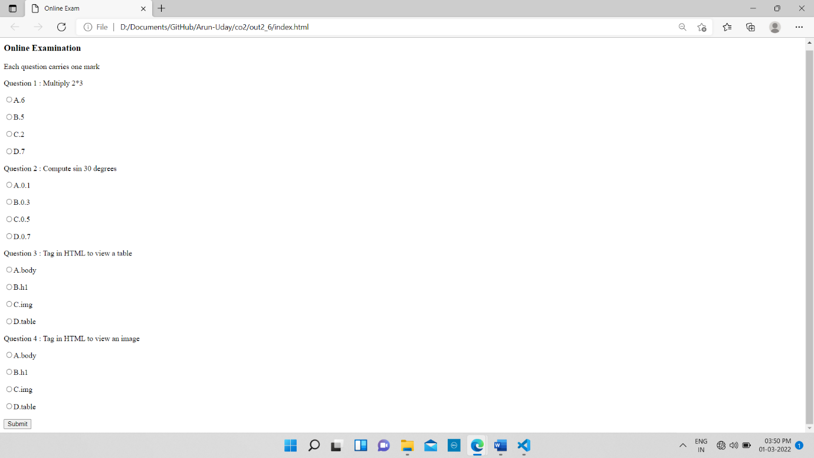

**RESULT:** The program was successfully executed and obtained the output

**PHP**

PHP (Hypertext Pre-processor) is a server-side scripting language designed for web development but also used as a general-purpose programming language. PHP is a widely used open-source general purpose scripting language that is especially suited for web development and can be embedded into HTML. Instead of lots of commands to output HTML, PHP pages contain HTML with embedded code that does something. The PHP code is enclosed in special start and end processing instructions <? php and ?> that allow you to jump into and out of PHP mode. What distinguishes PHP from something like client-side java script is that the code is executed on the server, generating HTML which is ten sent to the client. The client would receive the results of running that script, but would not know what the underlying code was. You can even configure your web server to process your entire HTML file with PHP, and then there’s really no way that users can tell what you have up yourselves.

The best things in using PHP are that it is extremely simple for a newcomer, but offers many advanced features for a professional programmer. PHP is mainly focused on server-side scripting, so you can do anything any other CGI program can do, such as collect form data, generate dynamic page content, or send and receive cookies.

**MYSQL**

MySQL is an open-source relational database management system (RDBMS). A relational database organizes data into one or more data tables in which data types may be related to each other; these relations help structure the data. SQL is a language programmers use to create, modify and extract data from the relational database, as well as control user access to the database. In addition to relational databases and SQL, an RDBMS like MySQL works with an operating system to implement a relational database in a computer's storage system, manages users, allows for network access and facilitates testing database integrity and creation of backups.

MySQL is free and open-source software under the terms of the GNU General Public License, and is also available under a variety of proprietary licenses. MySQL was owned and sponsored by the Swedish company MySQL AB, which was bought by Sun Microsystems (now Oracle Corporation). In 2010, when Oracle acquired Sun, Widenius forked the open-source MySQL project to create MariaDB.

**PROGRAM NO: 12**

**AIM:** Develop a PHP program to connect to a database and retrieve data from a table and show the details in a neat format

**DESIGN:**

1. Create a page with extension .php for connecting database and to retrieve data from database
2. Use HTML table tag for displaying the result

**SOURCE CODE:**

|  |  |
| --- | --- |
| index.html | <?php  $con = mysqli_connect("localhost","root","","emp_db");  if(!$con){  printf("Connection Failed : ",mysqli_connect_error());  }  else{  printf("Connection Successfull");  $query=mysqli_query($con,"SELECT * FROM emp_table");?>  <table border="1">  <tr>  <th>Employee ID</th>  <th>Employee Name</th>  <th>Job Name</th>  <th>Manager ID</th>  <th>Salary</th>  </tr>  <?php  if(mysqli_num_rows($query)>0){  while($row = mysqli_fetch_array($query)){?>  <tr>  <td><?php echo$row['id']; ?></td>  <td><?php echo$row['emp_name']; ?></td>  <td><?php echo$row['job_name']; ?></td>  <td><?php echo$row['mid']; ?></td>  <td><?php echo$row['salary']; ?></td>  </tr>  <?php }  }  else{?>  <tr>  <td colspan="2">No Rows Selected</td>  </tr>  </table>  <?php  }  }  ?> |

**OUTPUT:**

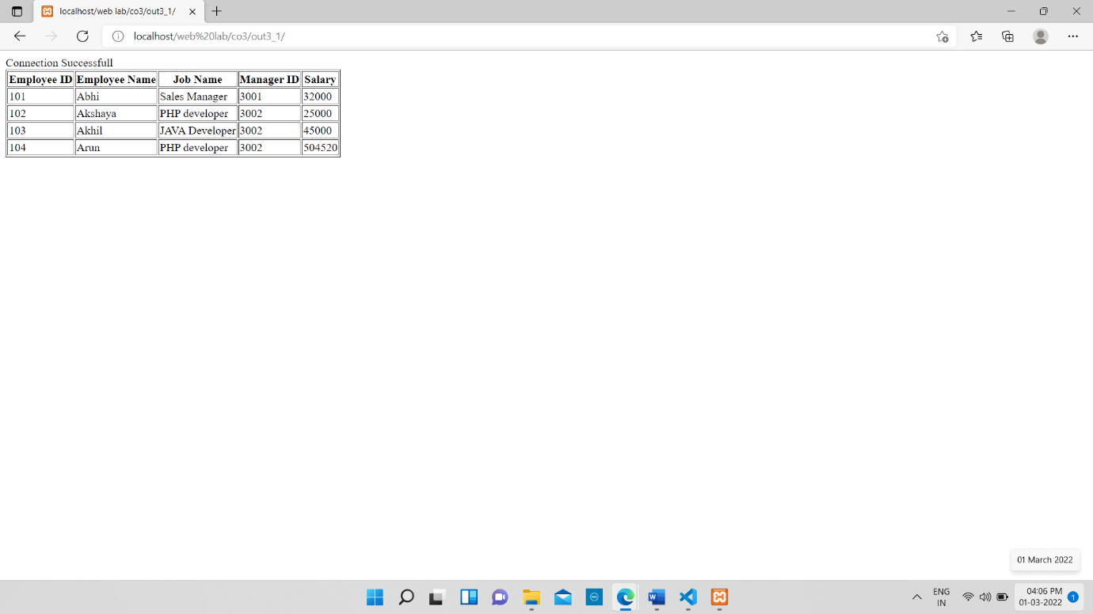

**RESULT:** The program was successfully executed and obtained the output

**PROGRAM NO: 13**

**AIM:** Outline a registration form using PHP and do necessary validations

**DESIGN:**

1. Create an HTML page containing fields for registration
2. Use PHP for validations

**SOURCE CODE:**

|  |  |
| --- | --- |
| index.html | <?php  if(isset($_POST['submit'])){  $name=$_POST['name'];  $email=$_POST['email'];  $phone=$_POST['phone'];  $pass=$_POST['pass'];  $cpass=$_POST['cpass'];  $flag=0;  if(empty($name)){  $msg['name']="*Name is required";  $flag=1;  }  if(empty($email)){  $msg['email']="*Email ID is required";  $flag=1;  }  if(empty($phone)){  $msg['phone']="*Phone No is required";  $flag=1;  }  if(empty($pass)){  $msg['pass']="*Pass is required";  $flag=1;  }  if(empty($cpass)){  $msg['cpass']="*Confirm password is required";  $flag=1;  }  if($flag==0){  if(!preg_match('/^[a-zA-Z ]*$/',$name)){  $msg['name']="*Invalid name";  $flag=1;  }  if(!filter_var($email,FILTER_VALIDATE_EMAIL)){  $msg['email']="*Invalid Email ID";  $flag=1;  }  if(!preg_match("/^[6-9]\d{9}$/", $phone)){  $msg['phone']="*Invalid Phone Number";  $flag=1;  }  if(!preg_match("/^[A-Z\d]/",$pass)||!preg_match('/[^\w]/', $pass)||strlen($pass)<8){  $msg['pass']="*Password should be at least 8 characters in length and should include at least one uppercase letter, one number and one special character";  $flag=1;  }  if($pass!=$cpass){  $msg['cpass']="*Passwords doesn't match";  }  if($flag==0){  echo"<script>alert('Registration Successful');</script>";  }    }  }  ?>  <!DOCTYPE html>  <html lang="en">  <head>  <meta charset="UTF-8">  <meta http-equiv="X-UA-Compatible" content="IE=edge">  <meta name="viewport" content="width=device-width, initial-scale=1.0">  <title>Registration Form</title>  <style>  body{  display: flex;  justify-content: center;  align-items: center;  }  form{  border-radius: 10px;  padding: 30px;  margin: 20px;  border:1px solid black;  }  input{  width:200px;  }  label{  display: inline-block;  width:300px;  }  div{  padding:10px;  }  span{  color:red;  }  </style>  </head>  <body>  <form action="" method="post">  <div>  <label>Name</label><input type="text" name="name" value="<?php if(isset($name))echo$name;?>">  <?php if(isset($msg['name'])){?><span><?php echo$msg['name'];?></span><?php }?>  </div>  <div>  <label>Email ID</label> <input type="text" name="email" value="<?php if(isset($email))echo$email;?>">  <?php if(isset($msg['email'])){?><span><?php echo$msg['email'];?></span><?php }?>  </div>  <div>  <label>Phone No</label> <input type="tel" name="phone" value="<?php if(isset($phone))echo$phone;?>">  <?php if(isset($msg['phone'])){?><span><?php echo$msg['phone'];?></span><?php }?>  </div>  <div>  <label>Password</label> <input type="password" name="pass">  <?php if(isset($msg['pass'])){?><span><?php echo$msg['pass'];?></span><?php }?>  </div>  <div>  <label>Confirm Password</label> <input type="password" name="cpass">  <?php if(isset($msg['cpass'])){?><span><?php echo$msg['cpass'];?></span><?php }?>  </div>  <input type="submit" value="Submit" name="submit">  </form>  </body>  </html> |

**OUTPUT:**

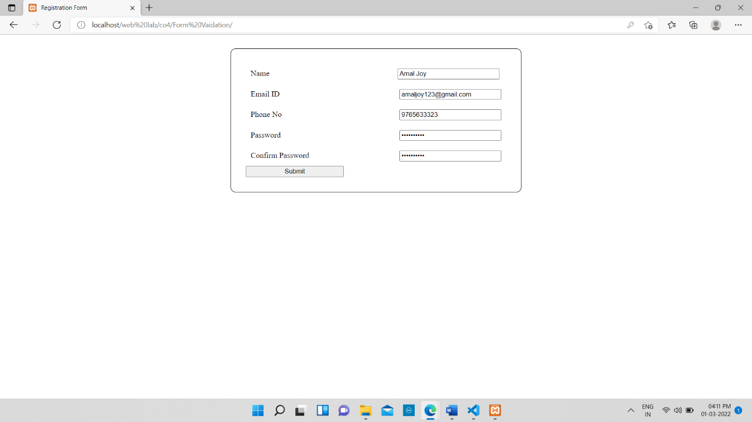

**RESULT:** The program was successfully executed and obtained the output

**PROGRAM NO: 14**

**AIM:** Compose Electricity bill from user input based on a given tariff using PHP

**DESIGN:**

1. Create an HTML page containing form for entering bill details
2. Use PHP for calculation

**SOURCE CODE:**

|  |  |
| --- | --- |
| index.html | <!DOCTYPE html>  <html lang="en">  <head>  <meta charset="UTF-8">  <meta http-equiv="X-UA-Compatible" content="IE=edge">  <meta name="viewport" content="width=device-width, initial-scale=1.0">  <title>Electricity Bill</title>  </head>  <body>  <form action="" method="POST" >  Enter the meter number : <input type="number" name="mnum" id=""><br>  Enter number of unit : <input type="number" name="unit" id=""><br>  Select the category : <select name="category" id="">  <option value="rural">Rural</option>  <option value="residential">Residential</option>  <option value="commercial">Commercial</option>  </select><br>  <input type="submit" value="Submit" name="submit">  </form>  </body>  </html>  <?php  if(isset($_POST['submit'])){  $mnum=$_POST['mnum'];  $unit=$_POST['unit'];  $tariff=$_POST['category'];  $se=0;  $rate=0;  if($tariff=='rural'){  if($unit>0 && $unit<=50){  $se=10;  $rate=($unit*.25)+$se;  }  else if($unit>50 && $unit<=100){  $se=10;  $rate=($unit*.50)+$se;  }  else if($unit>100 && $unit<=200){  $se=10;  $rate=($unit*1.0)+$se;  }  else if($unit>200 && $unit<=400){  $se=10;  $rate=($unit*1.25)+$se;  }  else if($unit>400){  $se=10;  $rate=($unit*1.50)+$se;  }  }  if($tariff=='residential'){  if($unit>0 && $unit<=50){  $se=10;  $rate=($unit*.50)+$se;  }  else if($unit>50 && $unit<=100){  $se=10;  $rate=($unit*1.0)+$se;  }  else if($unit>100 && $unit<=200){  $se=10;  $rate=($unit*1.25)+$se;  }  else if($unit>200 && $unit<=400){  $se=10;  $rate=($unit*1.50)+$se;  }  else if($unit>400){  $se=10;  $rate=($unit*2.0)+$se;  }  }  if($tariff=='commercial'){  if($unit>0 && $unit<=50){  $se=10;  $rate=($unit*1.0)+$se;  }  else if($unit>50 && $unit<=100){  $se=10;  $rate=($unit*1.25)+$se;  }  else if($unit>100 && $unit<=200){  $se=10;  $rate=($unit*1.50)+$se;  }  else if($unit>200 && $unit<=400){  $se=10;  $rate=($unit*2.0)+$se;  }  else if($unit>400){  $se=10;  $rate=($unit*2.25)+$se;  }  }  echo"Meter Number : ".$mnum."<br>";  echo"Surcharge : ".$se."<br>";  echo"Tariff category : ".$tariff."<br>";  echo"Unit : ".$unit."<br>";  echo"Total charge for (".$unit.") : ".$rate;  }  ?> |

**OUTPUT:**

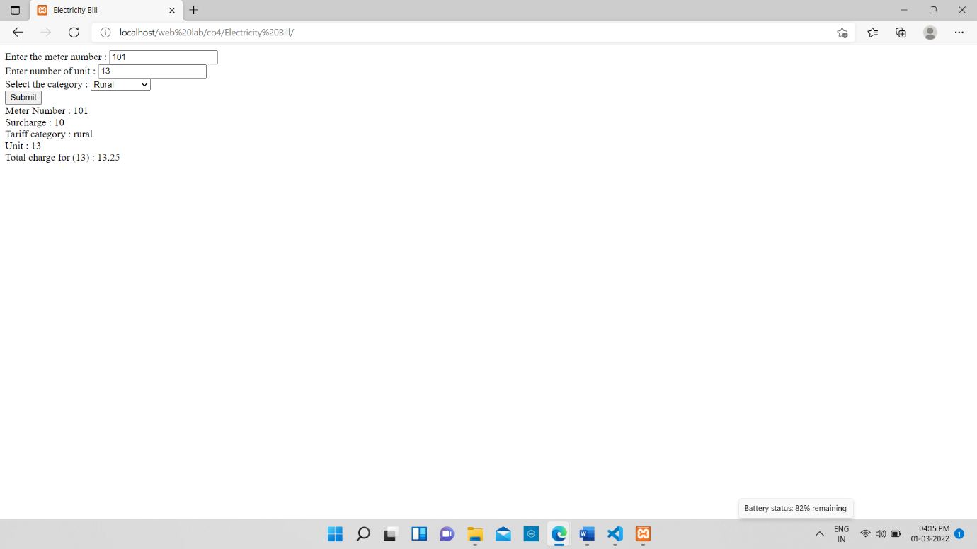

**RESULT:** The program was successfully executed and obtained the output

**PROGRAM NO: 15**

**AIM:** Build a PHP code to store name of students in an array and display it using print_r function. Sort and display the same using asort & arsort functions

**DESIGN:**

1. Create a page with extension .php
2. Use PHP to store names of students and display the data using print_r function

**SOURCE CODE:**

|  |  |
| --- | --- |
| index.html | <?php  $student=array("Ajin","Abhi","Sanoop","Manu","Nikhil");  print_r($student);  echo"<br>";  asort($student);  echo"asort : ";  print_r($student);  echo"<br>arsort : ";  arsort($student);  print_r($student);  ?> |

**OUTPUT:**

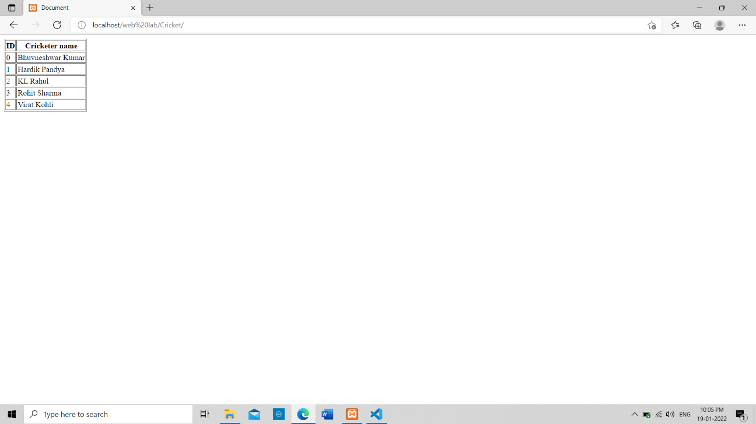

**RESULT:** The program was successfully executed and obtained the output

**PROGRAM NO: 16**

**AIM:** Build a PHP code to store name of Indian Cricket players in an array and display the same in HTML table

**DESIGN:**

1. Create a page with extension .php
2. Use PHP to store names of Indian Cricket
3. Display the stored details using table tags

**SOURCE CODE:**

|  |  |
| --- | --- |
| index.html | <!DOCTYPE html>  <html lang="en">  <head>  <meta charset="UTF-8">  <meta http-equiv="X-UA-Compatible" content="IE=edge">  <meta name="viewport" content="width=device-width, initial-scale=1.0">  <title>Document</title>  </head>  <body>  <?php $players=array("Bhuvneshwar Kumar","Hardik Pandya","KL Rahul","Rohit Sharma","Virat Kohli");?>  <table border="1">  <tr>  <th>ID</th>  <th>Cricketer name</th>  </tr>  <?php foreach($players as $key=>$name){?>  <tr>  <td><?php echo"$key";?></td>  <td><?php echo"$name";?></td>  </tr>  <?php }?>  </table>  </body>  </html> |

**OUTPUT:**

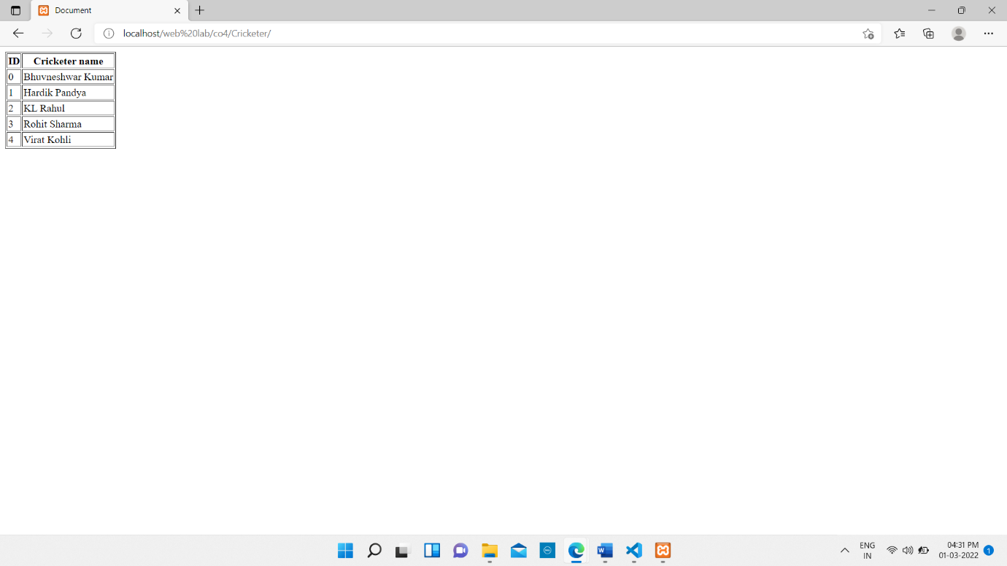

**RESULT:** The program was successfully executed and obtained the output

**PROGRAM NO: 18**

**AIM:** Using PHP and MySQL, develop a program to accept book information viz. Accession number, title, authors, edition and publisher from a web page and store the information in a database and to search for a book with the title specified by the user and to display the search results with proper headings

**DESIGN:**

1. Create an HTML page with form for reading data from using
2. Use PHP to connect to database and store data
3. Display the details of book with specific title using table tags.

**SOURCE CODE:**

|  |  |
| --- | --- |
| index.html | <?php  $con=mysqli_connect("localhost","root","","book_db");  if(mysqli_connect_errno()){  printf("Connection failed : ",mysqli_connect_error());  }  else{  $msg['con']="Database Connection Successfull";  if(isset($_POST['submit'])){  $no=$_POST['no'];  $title=$_POST['title'];  $auth=$_POST['auth'];  $edition=$_POST['edition'];  $publisher=$_POST['publisher'];  $flag=0;  if(empty($no)){  $msg['no']="*Accession number is required";  $flag=1;  }  if(empty($title)){  $msg['title']="*Title is required";  $flag=1;  }  if(empty($auth)){  $msg['auth']="*Author name is required";  $flag=1;  }  if(empty($edition)){  $msg['edition']="*Edition is required";  $flag=1;  }  if(empty($publisher)){  $msg['$publisher']="*Publisher is required";  $flag=1;  }  if($flag==0){  if(!preg_match('/^[0-9]*$/',$no)){  $msg['no']="*Invalid Accession number";  $flag=1;  }  if($flag==0){  $query=mysqli_query($con,"INSERT INTO book_table VALUES('$no','$title','$auth','$edition','$publisher')");  if($query){  $msg['err']="Data Inserted";  }  else{  $msg['err']="Insertion Failed";  }  }    }  }  }    ?>  <!DOCTYPE html>  <html lang="en">  <head>  <meta charset="UTF-8">  <meta http-equiv="X-UA-Compatible" content="IE=edge">  <meta name="viewport" content="width=device-width, initial-scale=1.0">  <title>Registration Form</title>  <style>  body{  display: flex;  flex-direction: column;  justify-content: space-between;  align-items: center;  }  form{  border-radius: 10px;  padding: 30px;  margin: 20px;  border:1px solid black;  }  input{  width:200px;  }  label{  display: inline-block;  width:300px;  }  div{  padding:10px;  }  span{  color:red;  }  </style>  </head>  <body>  <h3>REGISTRATION FORM</h3>  <form action="" method="post">  <div>  <label>Accession NO</label><input type="text" name="no" value="<?php if(isset($no))echo$no;?>">  <?php if(isset($msg['name'])){?><span><?php echo$msg['name'];?></span><?php }?>  </div>  <div>  <label>Title</label> <input type="text" name="title" value="<?php if(isset($title))echo$title;?>">  <?php if(isset($msg['title'])){?><span><?php echo$msg['title'];?></span><?php }?>  </div>  <div>  <label>Author</label> <input type="text" name="auth" value="<?php if(isset($auth))echo$auth;?>">  <?php if(isset($msg['auth'])){?><span><?php echo$msg['auth'];?></span><?php }?>  </div>  <div>  <label>Edition</label> <input type="text" name="edition" value="<?php if(isset($edition))echo$edition;?>">  <?php if(isset($msg['edition'])){?><span><?php echo$msg['edition'];?></span><?php }?>  </div>  <div>  <label>Publisher</label> <input type="text" name="publisher" value="<?php if(isset($publisher))echo$publisher;?>">  <?php if(isset($msg['publisher'])){?><span><?php echo$msg['publisher'];?></span><?php }?>  </div>  <input type="submit" value="Submit" name="submit">  <div>  <?php if(isset($msg['con'])){?><span><?php echo$msg['con'];?></span><?php }?>  </div>  <div>  <?php if(isset($msg['err'])){?><span><?php echo$msg['err'];?></span><?php }?>  </div>  </form>  <h3>Search Book</h3>  <form action="" method="post">  <label>Enter Title</label><input type="text" name="se" id="se">  <div>  <input type="submit" value="Search" name="search">  </div>  </form>  <?php  if(isset($_POST['search'])){  ?>  <table border=1 width="40%">  <tr>  <th>Accession No</th>  <th>Title</th>  <th>Author</th>  <th>Edition</th>  <th>Publisher</th>  </tr>  <?php  $query=mysqli_query($con,"SELECT * FROM book_table WHERE title LIKE '%$_POST[se]%'");  while($row=mysqli_fetch_array($query)){  ?>  <tr>  <td><?php echo$row['no']; ?></td>  <td><?php echo$row['title']; ?></td>  <td><?php echo$row['author']; ?></td>  <td><?php echo$row['edition']; ?></td>  <td><?php echo$row['publisher']; ?></td>  </tr>  <?php  }  }  ?>  </table>  </body>  </html> |

**OUTPUT:**

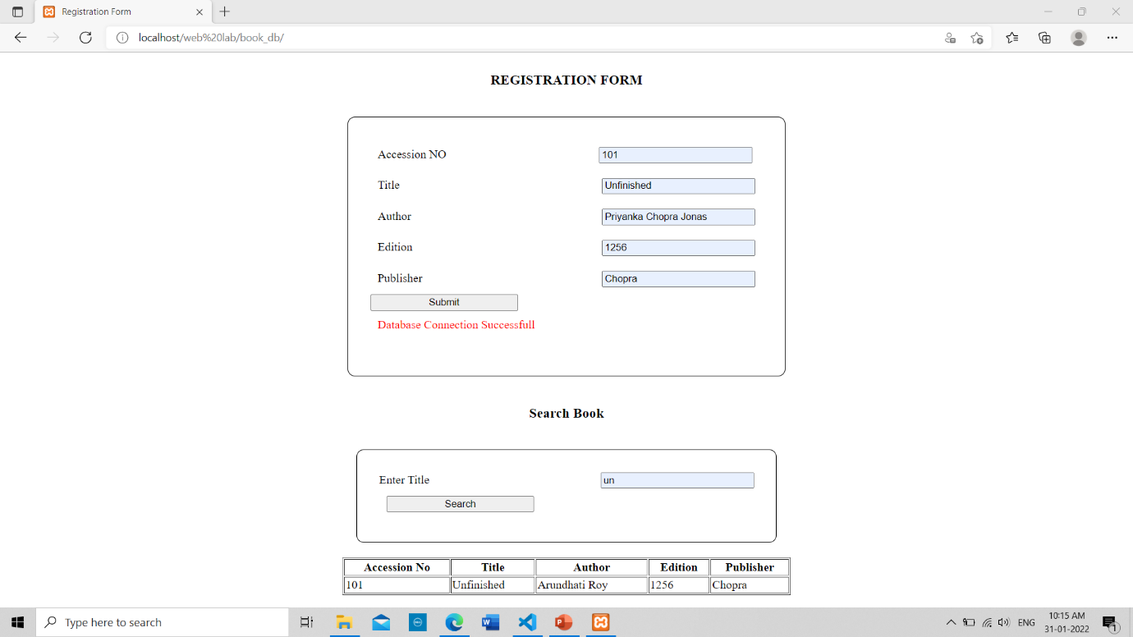

**RESULT:** The program was successfully executed and obtained the output